INST 201 Introduction to International Studies
Middle East & North Africa
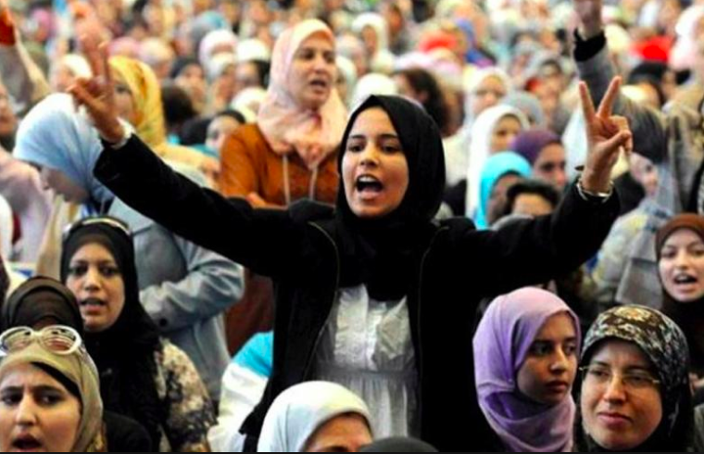
Source: Morocco World News

Geographical Scope
Variable definition
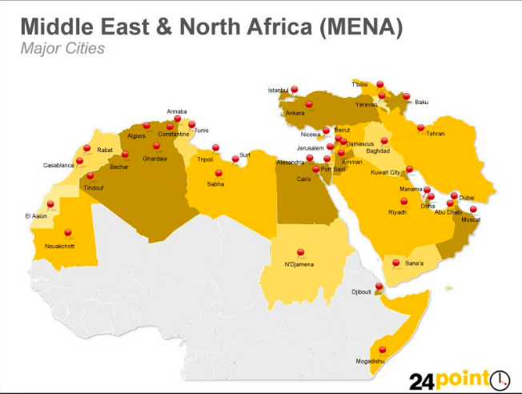

Core countries
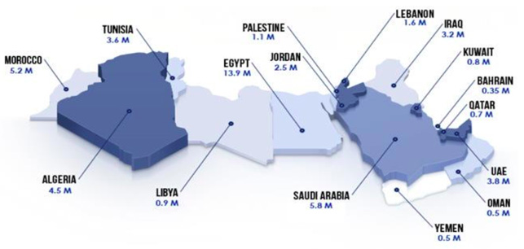
Metric is number of Facebook users
Source: ICEF
Sometimes Western Sahara and Mauritania are included
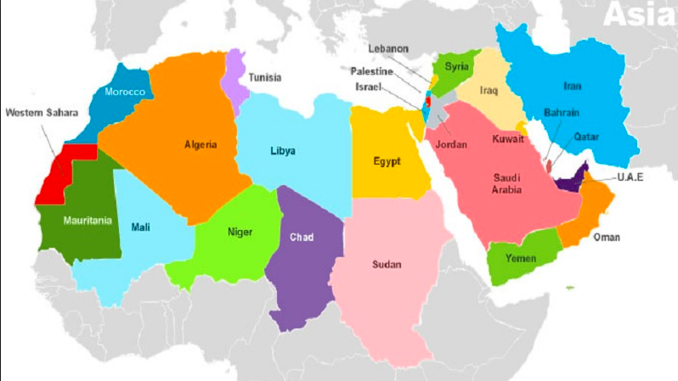

Sometimes Afghanistan and Pakistan are included
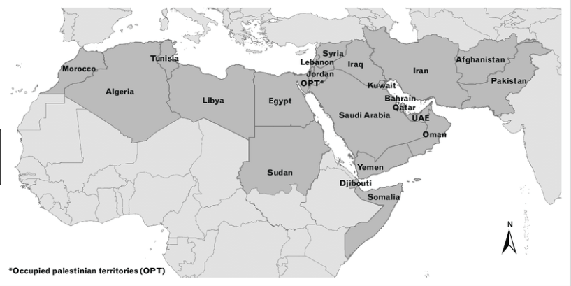
The scope preferred by Dr B (and most commonly used):

The Middle of Where?

From Past to Present

Diversity and Division

From Empires to Nation-States

The Richest and the Poorest
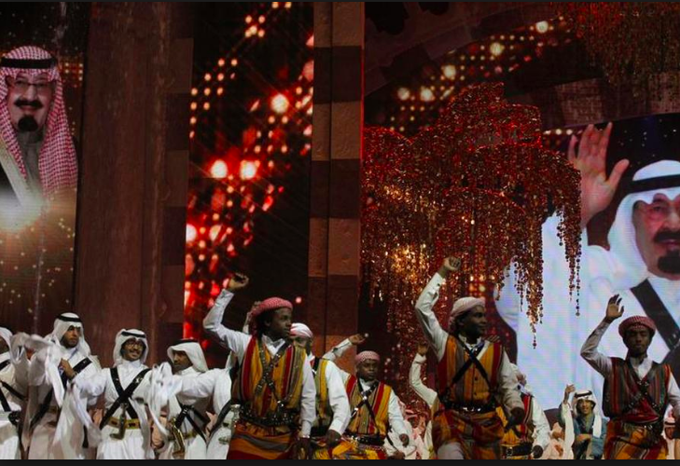
The Problem of Palestine

Political Turmoil in the Middle East

Middle East Prospects

Resources on MENA
World Bank
OECD

Pew

IstiZada.com

