INST 201
History as an Approach to International Understanding

History definition given in our text:

History is a written, oral, or visual reconstruction and interpretation of past human endeavors based on available sources (15).

Historia – From the Latin root for inquiry

What do historians do and how do they do it?

“Historians examine and reexamine new evidence to reframe the past or to confirm previous accounts” (18)

I would re-word this to say “Historians seek out new evidence, previously unknown accounts, artifacts, pieces of the puzzle they are trying to fill in and re-examine old evidence from new perspectives.”

Causation – is this what historians seek?

Yes, no, maybe

If not, what do they seek?

Positivism
“The role of the historian is to seek objectivity and truth, through marshalling evidence (primary sources, artifacts) and striving to set aside his/her biases”

What do you think?
Sound reasonable?
Possible?
A worthy aspiration?
Explain.

“Reliable histories depend on the skill and thoroughness of historians,
the cogency of their logic, and
the conscious subordination of the biases that they bring to their work.” (18)

Can this be done?

Post-modernism
Begins from the premise that all histories are partial, incomplete, filtered through the eyes of the observers, recorders and that some people’s experiences are not part of that record

Other factors to consider that affect
“the historical record”
“a specific person’s account”

Cultural mediation, racial, class, gender privilege (or subordination – e.g., bottom-up view)

Revisionist History
Example: Jan Gross’s Neighbors (2001)

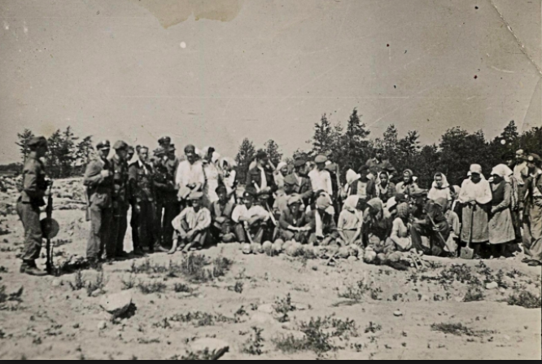

Chronicle story

New law
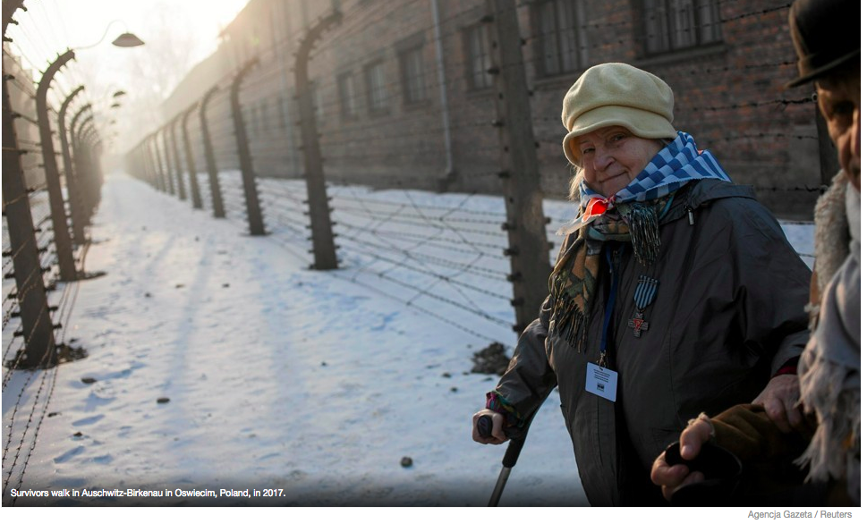

What does the changing conversation about Polish history, experience of WWII tell us about the role of history and the historian?

***History, historical accounts and the conversations, controversies and new understandings they generate matter.

**Competing narratives, multiple narratives

What counts as evidence for historians?

Primary vs secondary sources

Examples of each

Disciplinary subfields of History:
Political and diplomatic history
Economic history
Business history
Labor history
Cultural and social history
Intellectual history
History of science and technology
Environmental history

Other ways to divide the field:
periods/eras
regions
methods
perspectives

