INST 201 Introduction to International Studies
Power, Conflict, and Policy: The Role of Political Science in International Studies
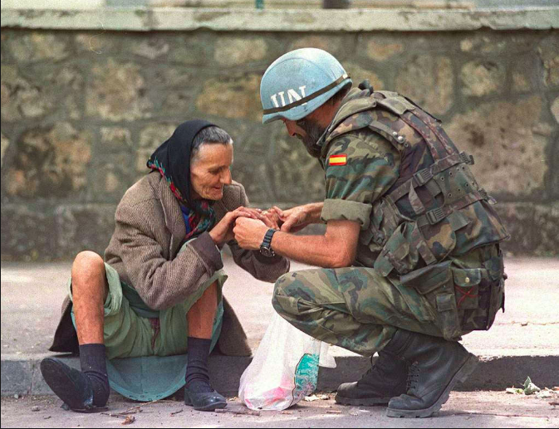
Source: https://hiveminer.com/Tags/unprofor/Timeline

What is Political Science?

Comparative Politics vs International Politics

Examples of Comparative Politics Research Questions
What makes democracies stable over time?
What explains a country’s level of corruption?

Examples of International Relations Research Questions
What type of organization is better at deterring armed conflict between neighboring countries: bi-lateral, multi-purpose organizations; bi-lateral security pacts; multi-lateral multi-purpose organizations; or multi-lateral, security organizations?
Is there evidence that the Declaration of Human Rights has reduced human rights violations worldwide?

Area Studies

Area Studies Sources:
African Studies Association:
https://africanstudies.org/

African Union:
https://au.int/

Asia-Pacific Economic Cooperation:
https://www.apec.org/

Association for Asian Studies:
http://www.asian-studies.org/

Caribbean Studies Association: http://www.caribbeanstudiesassociation.org/

Council for European Studies:
https://councilforeuropeanstudies.org/
Eurasian Economic Union: http://www.eaeunion.org/?lang=en

Latin American Studies Association: https://lasa.international.pitt.edu/eng/
Organization of American States (OAS):
http://www.oas.org/en/

Association for Slavic, East European and Eurasian Studies (ASSEES): http://www.aseees.org/

East European Politics & Societies: http://journals.sagepub.com/home/eep

Recommended sources on CP
Journal of Comparative Politics:
http://jcp.gc.cuny.edu/

Comparative Political Studies:
http://journals.sagepub.com/home/cpsa

Recommended sources on IP
Theories of International Politics and Zombies

World Politics:
https://www.cambridge.org/core/journals/world-politics#

Organization for Security and Cooperation in Europe: https://www.osce.org/

NATO: https://www.nato.int/

Political Science
American Political Science Association: http://www.apsanet.org/

