Eurasian Politics

Everyday Life in Central Asia

Soviet Impact on Nomadism and Women’s Roles (Chpts 2 and 8)

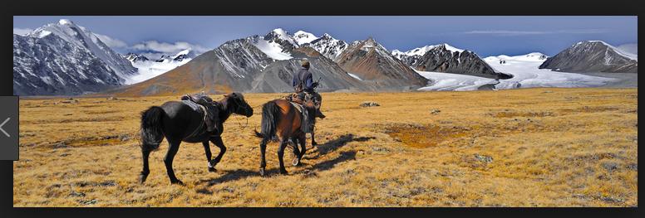

[Central Asian Nomads](https://www.google.com/search?client=firefox-b-1-d&q=central+asian+nomads)

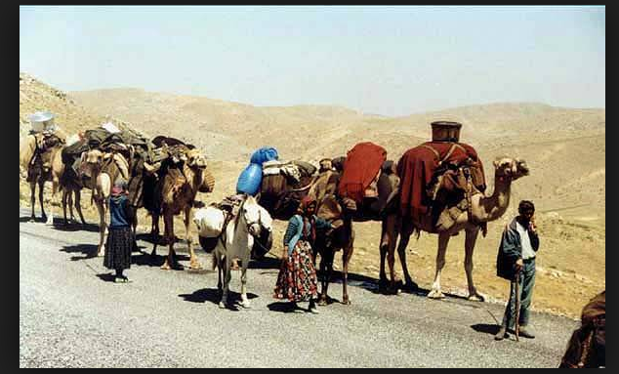

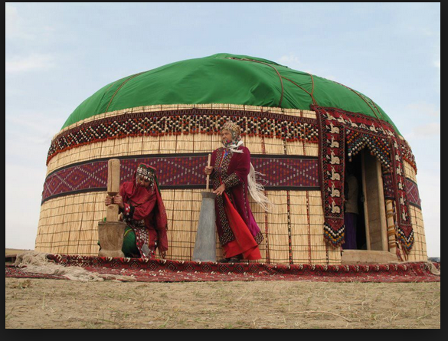

Sovietization

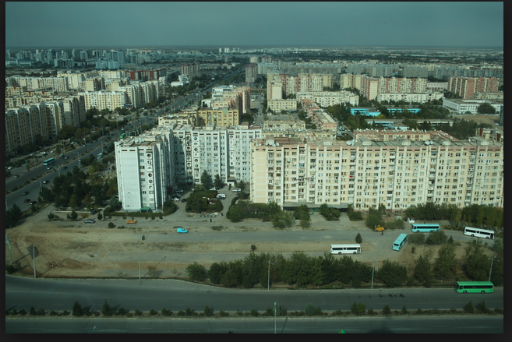

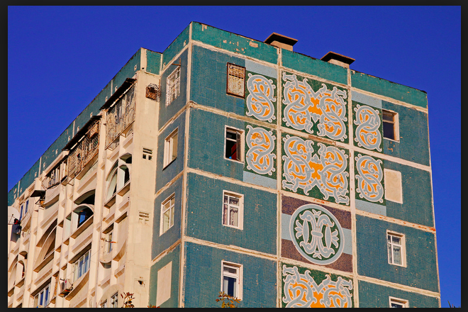

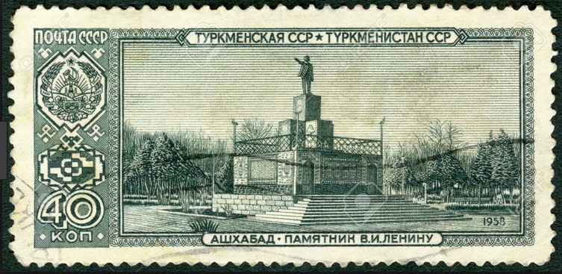

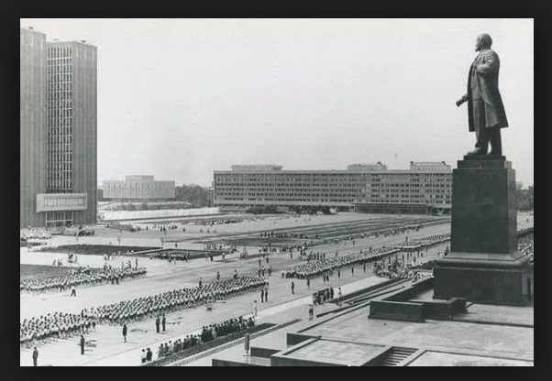



[Uzbek women](https://www.google.com/search?client=firefox-b-1-d&biw=1280&bih=711&tbm=isch&sa=1&ei=HtpuXIqPI4zw_wTQ3obIBQ&q=women+uzbekistan&oq=women+uzbekistan&gs_l=img.3...218549.228406..228708...4.0..0.59.1416.33......0....1..gws-wiz-img.....0..0i24j0i30j0i8)

Traditional women’s roles

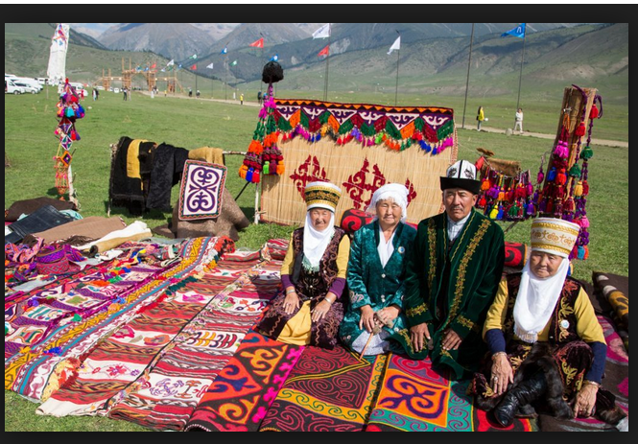

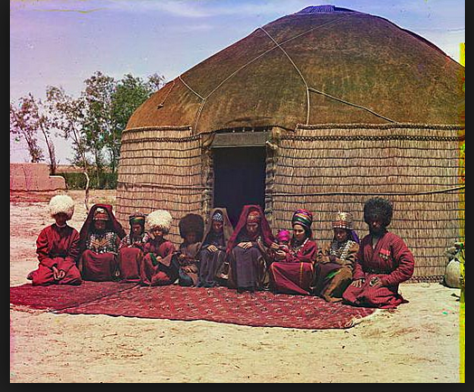

Sovietization

