INST 201
Introduction to Geography
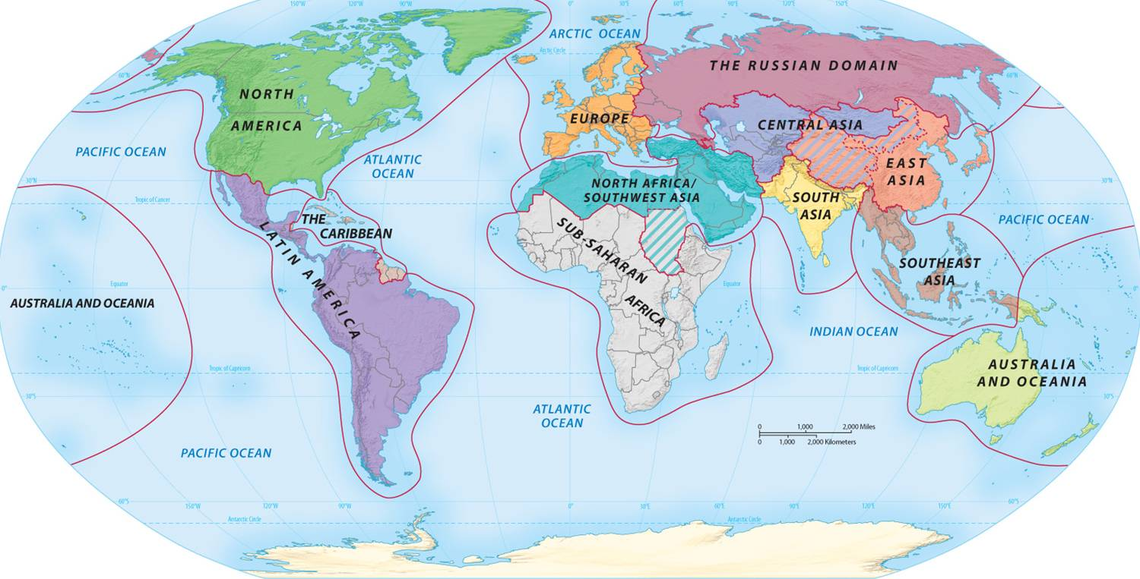

Chpt begins with statement: geography “not necessarily deterministic but…”

Evaluate this statement

What does it mean for something to be deterministic?

How strong an influence DO we think geography (i.e., PHYSICAL geography) has on a country/region/people’s development??

Geography – what does it mean?
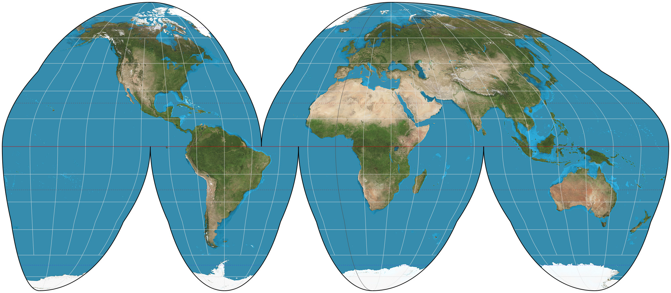
Source: GeoAwesomeness

Derivation of word in English:
Greek
Geo = Earth
Graphy = Writing

Thus, geography is a “writing” or DESCRIPTION of the earth

Chinese word for: dili
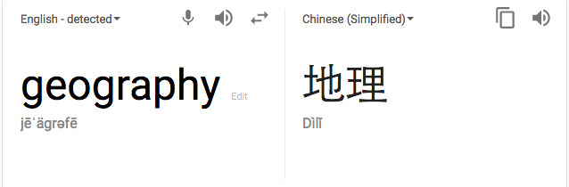
Di = earth
Li = pattern or arrangement

Thus, “geography” in Chinese means
The patterns ON or OF the earth

Which meaning do you prefer and why?

Academic definition given: “Geography is the study of where natural environments and human activities are found on Earth’s surface and the reasons for their location (Rubenstein et al. 2013)

What does this definition add to the meanings of geography above?

Authors on to note that there are TWO BRANCHES of geography: What are they?

PHYSICAL and HUMAN

***Overlaps with anthropology, sociology, political science, religious studies, economics in seeking to explain:

HOW people live;
WHY they chose to live that way;
HOW and WHY the patterns of social, economic and political organization we find across the globe DEVELOPED.

Also sometimes asks: can these patterns be changed? How?

Some geographical patterns in today’s world

Development a la Human Development Index
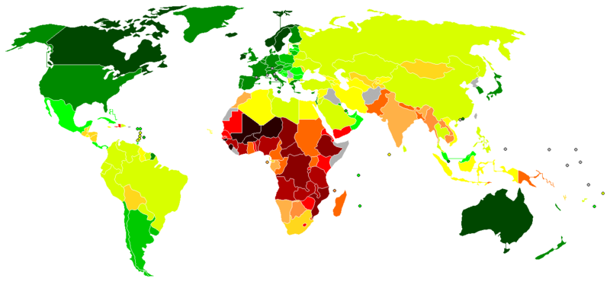
Source: Geographybylizz

Patterns of Religion across the World
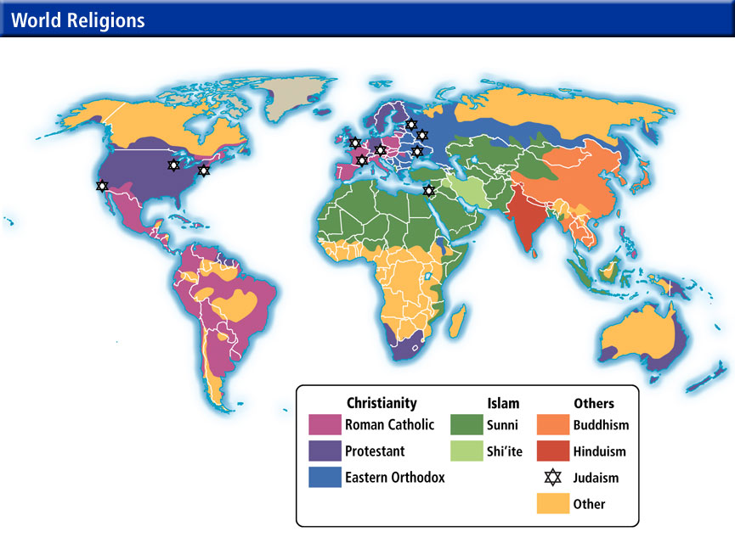
Source: Matt Beat’s Map Gallery,University of Omaha, GEOG1000
“Civilizations” a lá Samuel Huntington’s “Clash of Civilizations” thesis (Wikipedia entry) (book)
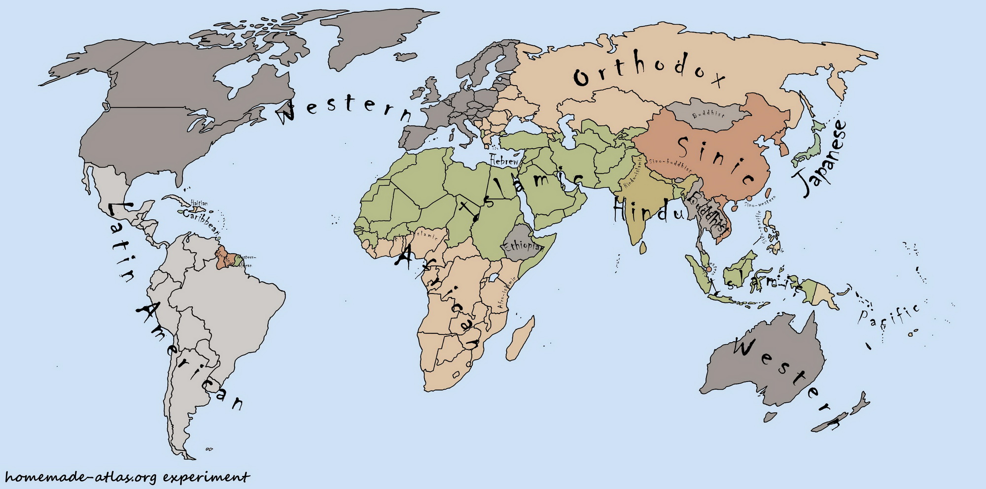
Source: Wikimedia Commons

World Regional Geography
Source: Gary Booher’s World Regional Geography course website at El Camino College

Development of Geography as a Field of Study
See p. 38 – note order – why?

History
Oldest geographical work: Tribute of Yü
Yü the Great

The Nine Provinces
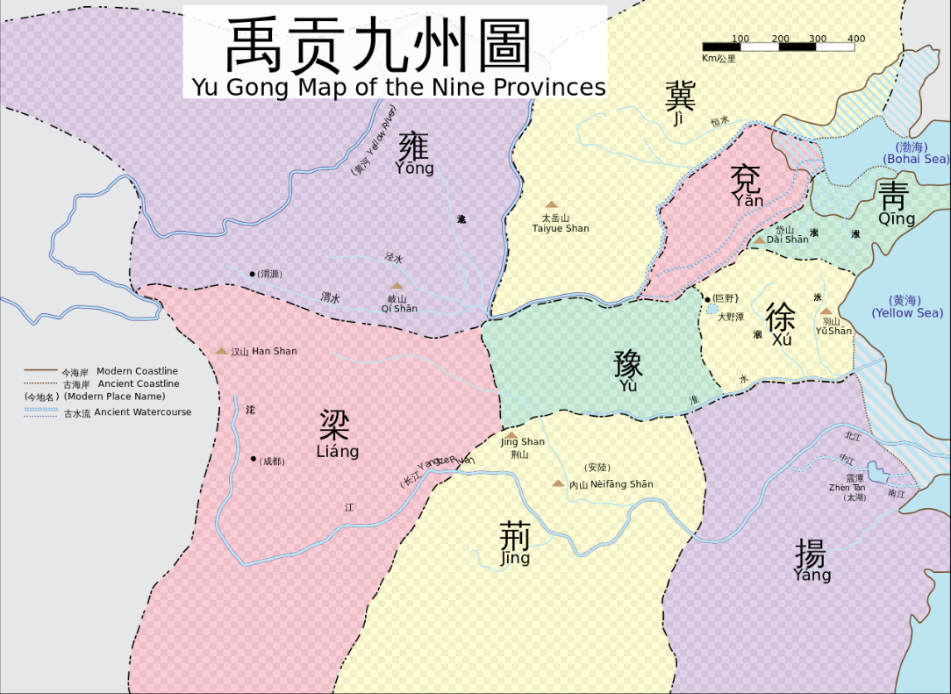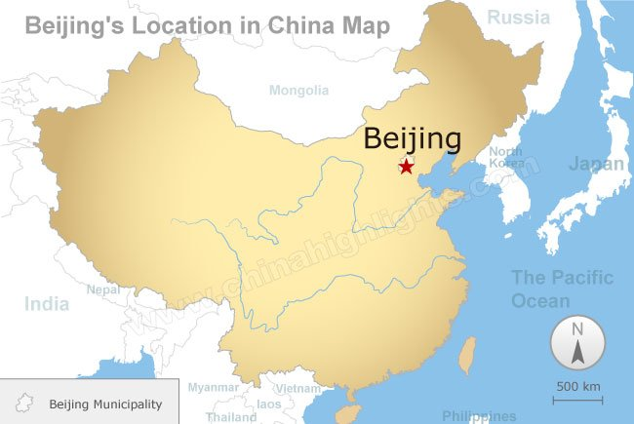
Chinaknowledge entry on Tribute of Yü
Wikipedia entry on Tribute of Yü

Then the Greeks
Eratosthenes (275- 195 BCE)
Library at Alexandria

After Fall of Roman Empire 476 CE (5th Century)– Europe enters the Dark Ages
Knowledge “lost”

Really preserved by Arabs in Caliphate, 8th Century

Relearned by Europeans in the Renaissance

Modern Geography as discipline developed in 20th C

US students poor at…why? (39)

More than just maps: BUT maps are also IMPORTANT

Components: Space, Regions, Environment

