INST 201
Introduction to International Studies
Spring 2019

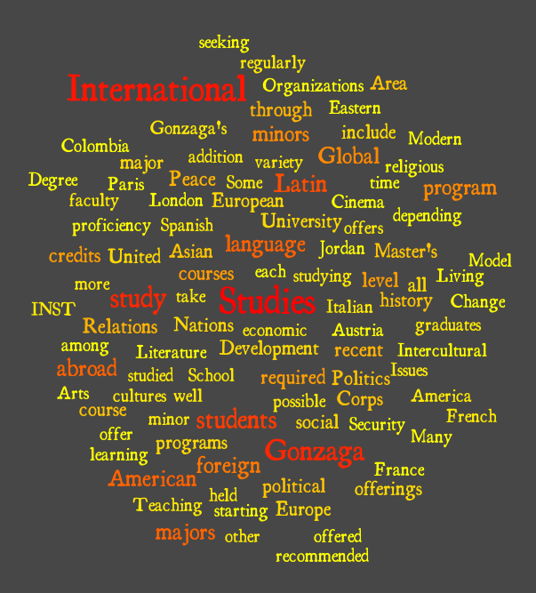

Dr. Brunell
Office: CG 044E
Office Hours: T 11-1; Th 3:30-5
brunell@gonzaga.edu

Teaching Philosophy and Policies (can also be found online here)
For me, being an effective teacher means being a life-long learner. In the past few years, I have been a student in Russian language classes at Moscow State University and here in Spokane through Spokane Parks & Rec (many thanks to my generous and patient teachers, Olga and Natalya, and my fellow students who have suffered my middle-aged brain!!) I’ve practiced speaking Russian and Polish with friends. I have explored the mandolin, poetry, theatre, fine arts, and traditional Polish paper-cutting. Daily, I struggle to keep up with technology with the best of them.

These experiences are profoundly humbling!! They remind me that learning new things requires incredible amounts of energy, persistence and organization. It’s a lonely road that offers me the refuge in the companionship of others.

That’s why I embrace the Ignatian principle of accompaniment, which means we are accompanying each other through this adventure of life and life-long learning. We simply cannot do it any other way.

In my vocation of teaching, I am accompanying my students on our shared journey of being and becoming curious, educated, at-times- expert, at-times-novice, empowered citizens of the world.
I expect students to take responsibility for their learning and to serve as companions to each other. This means doggedly pursuing information pertaining to our subjects of interest; asking challenging questions of oneself, of me and of one’s peers; and consistently contributing to the learning of others by being a responsible learner and good citizen of the classroom. Students and professor share the following roles: reader, listener, analyzer, challenger, debater, researcher, collaborator, writer, presenter.

I translate the above into this process:
see it, read it, write it, hear it, say it, hear it again, write it again, say it again, read some more about it, organize it and present it to others, i.e., share it.

Most of all: THINK, REFLECT, THINK SOME MORE. READ and READ SOME MORE.

Learn Thyself. That is, learn how you learn.

Attendance, Participation, and Tardiness
Students are expected to attend every class session, to read the works assigned, and to complete any other work appearing on the week-by-week course plan for that class session. If students read the materials closely, they should find it impossible not to have questions and other intellectual and emotional reactions to them!!

It is every student’s responsibility to seek clarification and to challenge the materials read for class.

Coming late, leaving early: we are all late sometimes. Don’t make it habit. If you are late or if you must leave early, please do so as inobtrusively as possible out of consideration for me and your classmates.

Late Work and Missed Exams
I accept late work and allow students to make-up missed exams on a case-by-case basis. Life happens. Wherever possible, make arrangements ahead of time if you have to miss class for extra-curricular activities, family responsibilities, medical treatment, etc.

Diversity and Non-Discrimination
Diversity affirms my faith-inspired commitment to an inclusive community where human differences thrive within a campus community of equality, solidarity, and common human nature. I seek to nourish difference in an environment characterized by mutual respect and the sustainable creation of a campus climate that attracts and retains community members from diverse backgrounds. In this context, age, gender, ethnicity, disability, social class, religion, culture, sexual orientations, language and other human differences all contribute to the richness of our academic community life. These differences grace us individually as human being and collectively as a Jesuit, Catholic and humanistic university striving to fulfill our Mission.
I aspire to create a university environment that is welcoming and accessible to all staff, faculty, students, and other members of the Gonzaga community regardless of gender, race, ethnicity, religion, disability, or sexual orientation.

I do not intend to discriminate against any person on the basis of race, color, religion, national origin, sex, marital status, sexual orientation, gender identity, age, disability, veteran status, or any other non-merit factor in employment, educational program, or activities that it operates.

I need your help in attaining these goals. Please bring it to my attention if I have been insensitive.

Resources and policies regarding diversity, equity & inclusion at Gonzaga can be found here.

Title IX
Reporting Sexual Misconduct, Intimate Partner Violence or Gender-based Harassment
Support for Students

Academic Advising & Assistance
Please click on this link for complete information on resources to enhance student learning at Gonzaga. I fully support all students in creating a learning and testing environments that maximizes their strengths and aptitudes.

Course Description for INST 201:
The course provides an introduction to the multi-disciplinary field of International Studies. It draws upon the disciplinary expertise of anthropology, economics, geography, political science, sociology, and religious studies.

Course will be punctuated by visits from representatives of the Study Abroad office, Center for Global Engagement, International Student Programs, faculty affiliated with the International Studies Department, alumni and current students with experiences to share about study abroad, internships, Washington Semester, etc.

Learning Outcomes:
Defining International Studies.
The ability to define the field of International Studies in terms of the diversity of disciplinary approaches and methods that comprise it [assessed in midterm exam].

Knowledge of the INST major and minor degree requirements.
Familiarity with opportunities for and the importance of studying foreign language; studying and serving abroad; undertaking an internship with an international component; possible careers with international dimensions; how to prepare for international careers.

Knowledge of Global Systems
Students should demonstrate college-level knowledge of the systems that organize the globalized world, e.g., global social systems, cultures and inter-culturality; international trade and economics; international law, organizations and politics. [pre- and post-course in-class assessment – not graded]

Global Studies Designation Learning Outcome 3:
Students will be able to demonstrate attitudes that reflect curiosity, openness to difference, and critical reflection when encountering values and belief systems that are different from their own.

Social and Behavioral Sciences Learning Outcome 3:
Students will be able to explain at least one way that a discipline in the social and behavioral sciences interprets and contributes to global social justice.

Text to Purchase:
Anderson, Sheldon, Mark Allen Peterson, and Stanley Toops. 2018. International Studies: An Interdisciplinary Approach to Global Issues. Fourth Edition. Boulder, CO: Westview Press.

Graded Elements of the Course:
Attendance and Participation 10 pts
3 Quizzes @ 10 pts each 30 pts
Research Bibliography 10pts
Paper on an issue of contemporary significance/global social justice affecting a region of student’s choice 20 pts
Group presentation on how the same issue of global social justice is affecting multiple regions of the world and contemporary solutions to it 10 pts
Final Reflection Paper on how the approaches of the disciplines of INST help one more completely understand an issue of contemporary significance and can contribute to a more socially just world 20 pts

Week-by-Week Course Schedule
Course Meets: T/R 1:50-3:05 pm, PACCAR 103

WEEK 1
Tuesday, January 15 Intro to course and each other

Thursday, January 17
Peoples, Places and Patterns: Using Geography to Understand the World
Reading: pp. 37-44, Chpt. 2 in textbook

WEEK 2
Tuesday, January 22
Peoples, Places and Patterns: Using Geography to Understand the World
Reading: pp. 45-50 (stop at section on Maps), Chpt. 2 in textbook

Thursday, January 24
Peoples, Places and Patterns: Using Geography to Understand the World
Reading: pp. 50-end, Chpt. 2 in textbook AND “Prisoners of Geography,” by Ricardo Hausman, Foreign Policy, Jan/Feb 2001, pp.44-53.

WEEK 3
Tuesday, January 29
Geography Quiz
Anthropology, Intro to the Study of Cultures and Peoples
Reading: pp. 63-73, Chpt. 3 in textbook

Thursday, January 31
Levels of Culture
Reading: pp. 73-77 in textbook

WEEK 4
Tuesday, February 5
Intercultural Relations
Reading: pp. 77-end of Chpt. 3 in textbook

Thursday, February 7
The Past in the Present: What is History?
Reading: pp. 13-22, Chpt. 1 in textbook

WEEK 5
Tuesday, February 12
Historical Interpretation in International Conflict
Reading: pp. 23-end of Chpt. 1 in textbook

Thursday, February 14
Quiz 2: Culture and History
Economics and International Development
Reading: pp. 91-109, Chpt. 4

WEEK 6
Tuesday, February 19
Economics and International Development
Reading: pp. 109-end of Chpt. 4

Thursday, February 21
Power, Conflict and Policy: Nation-states and Non-State Actors in the Global System
Reading: pp. 125-134, Chpt. 5

WEEK 7
Tuesday, February 26
Power, Conflict and Policy: Nation-states and Non-State Actors in the Global System
Reading: pp. 134-end of Chpt. 5

Thursday, February 28
Quiz 3 on Economics and Political Science approaches

WEEK 8
Tuesday, March 5
Space for guest

Thursday, March 7
Transition to Research Projects and Regional Studies

Tuesday, March 6: Presentation topics finalized. Bring to class, paper stating what region and issue you would like to focus on and why? What global problems most concern us as global citizens concerned with social justice?

Spring Break Week! March 11-15
Midterm Grades due Tuesday, March 12

WEEK 9
Tuesday, March 19
Hands-on research session at Foley

Thursday, March 21
Regional Introduction to Sub-Saharan Africa and the International Community

WEEK 10 – Dr B at conference – sub or film
Tuesday, March 26

Thursday, March 28

WEEK 11
Tuesday, April 2
Regional Introduction: East Asia and the Pacific; Demography and Development

Thursday, April 4
Regional Introduction and presentations: Latin America

WEEK 12
Tuesday, April 9
Regional Introduction: Middle East and North Africa

Thursday, April 11
Regional Introduction: South and Central Asia; Environment and Population

WEEK 13
Tuesday, April 16
Group Pres

Thursday, April 18
Group Pres

WEEK 14
Tuesday, April 23
Group Pres

Thursday, April 25
Group Pres

WEEK 15
Tuesday, April 30
Group Pres

Thursday, May 2
Course Wrap up and review for final

FINALS WEEK/END OF SEMESTER
Final Reflection Papers due by time for Final Exam
Thursday, May 9, 10:30-12:30

