INST 201 Introduction to International Studies
Economics and International Development

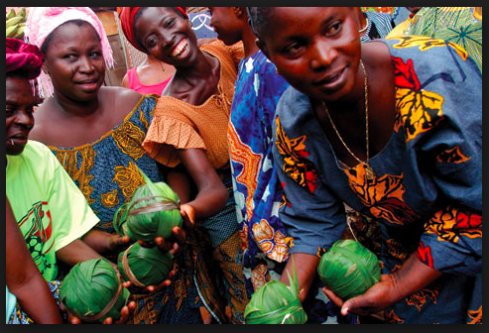
Source: Morocco World News

What is Economics?

The Dismal Science

“Economics is the social science that studies, describes, models, and makes predictions about the production, distribution, and consumption of goods and services.”

“It does so by focusing on the choices made by individuals (?) about alternative uses of (scarce) resources to satisfy needs and wants (97).”

Liberal Economics aka Classical Economics: What’s Liberal about it?
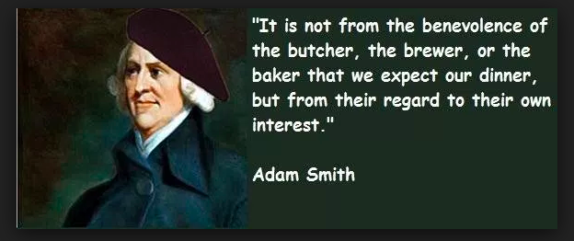

All people (economic actors) are
rationally self-interested – seeking maximum benefit at minimum cost.

Competition and freedom from coercion key.

Markets are most efficient when they are free from government regulation.

Neo-liberal economics
Milton Friedman
Free trade
WTO
NAFTA

Economic Nationalism

Using the State to pursue national economic interests, advantages

In contrast to liberal econ

Tariffs, protectionism, etc.
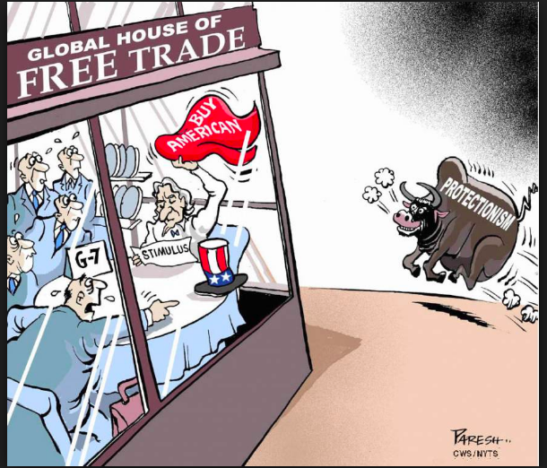

Marxism
Historical Materialism
Class antagonism
Ownership of the means of production
Nationalization

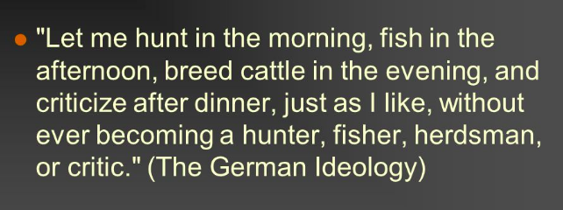

Micro vs Macro
Micro – the behavior of individuals, or individual firms; rational actor model; mini-max behavior, supply and demand to understand relative prices.

Macro – combined performance of all markets in a market system (e.g. national or regional economy)
Role of states in steering the economy through government spending and manipulation of the money supply.

Macroeconomic indicators
GDP, GDP per capita, unemployment, inflation, etc.

Development Economics
Developing countries: countries where the standard of living is consistently low relative to “first-world” economies of US, W Europe, Canada

How can all countries become wealthier, more productive, enjoy higher standard of living?
Stage theory (modernization theory)
Dependency theory

Why do economic development efforts so often fail to have their intended impact? Long term growth?

Cultural logics (what the book says)
Why else?
Globalization
Expansion of global communication and market connections, growing social and political interdependence, “planetary” rather than national or local consciousness on part of people
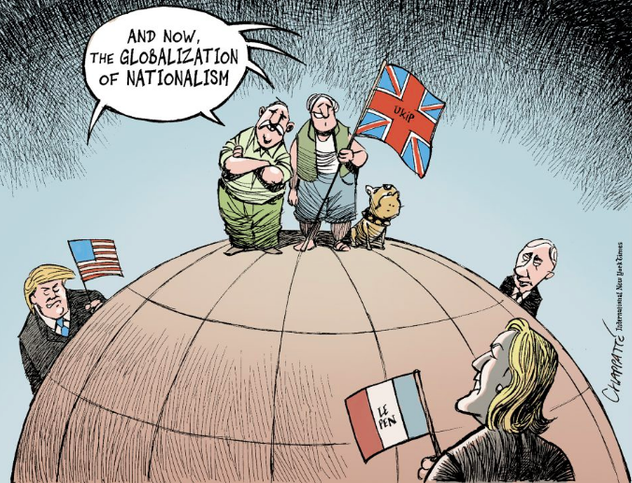

Who benefits from globalization? How are the costs and benefits of globalization spread across the world?

Non-Western Economics
Dispels the myth that human are universally “rational actors,” defined as being driven to consumer: more stuff, more pleasure, more everything, “More is better.”
The assumption of growth drive by insatiable (totally elastic) demand.

Rather, !Kung have limited wants, limit their work activity to afford them more leisure time, more family time, more communal time

Sahlins (1972) argued that different cultural logics create different forms of “rationality” and different economic behaviors

Sustainability
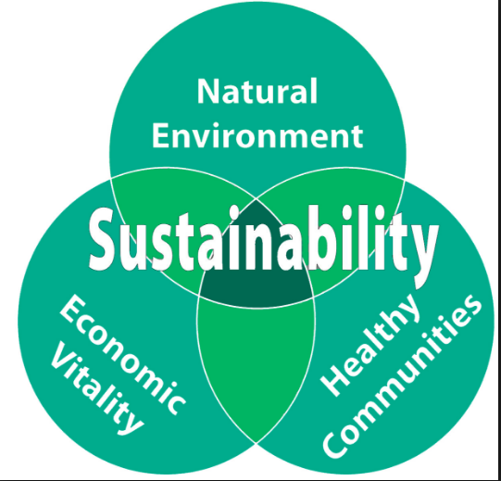

“the capacity of a political economic system to meet the needs of present communities without reducing the ability of future generations to meet their own needs” (118)

There are indeed communities, cultures who build sustainability into their economic choices rather than being short-sighted, driven by greed (scarcity) that defines the “rational” action as exploiting as much of a resource as you can before someone else does (zero-sum)

e.g., the Spokane and other Native American peoples; farmers in Nigeria and Switzerland

Incorporating Economics into your International Studies Degree

Double major or major/minor in Econ and INST – in School of Business

Or, more commonly,

College of Arts & Sciences

BS vs BA at GU

Or

Just take ECON 200 or ECON 201 and 202
And Global Economic Issues (esp bottom billion)

Recommended Economics Sites:
OECD
World Economic Forum
World Bank
ILO

Sustainability, sustainability and development
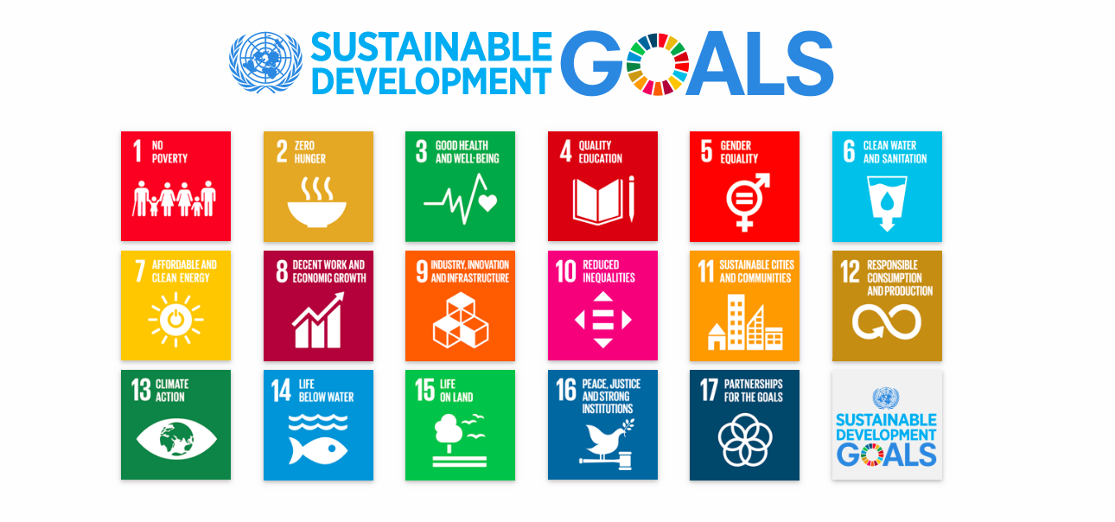
UNDP Sustainability Goals
Wedo.org
Wedo.org.pk
UCLA Sustainability

