Politics of Eurasia
Religion in Central Asia Today

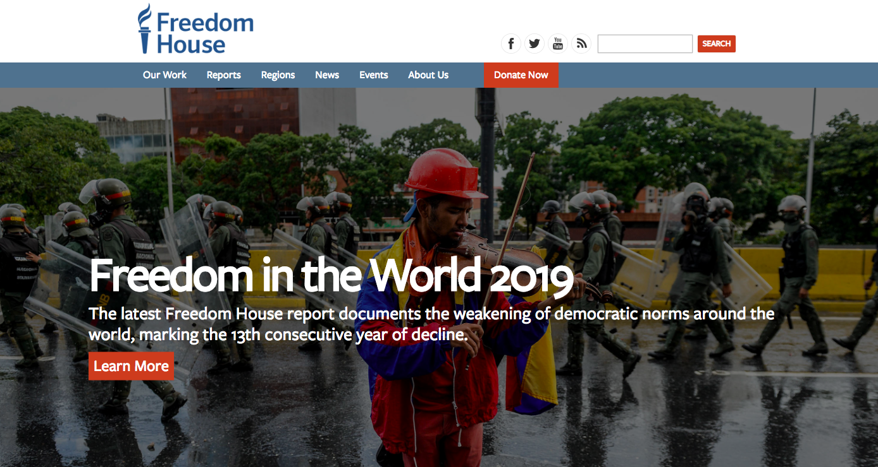

Uzbekistan
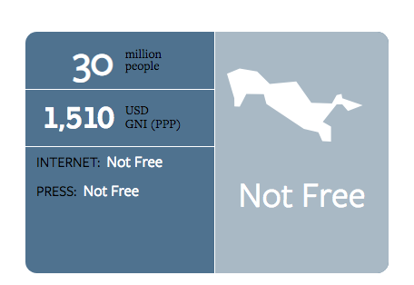

Islam Karimov
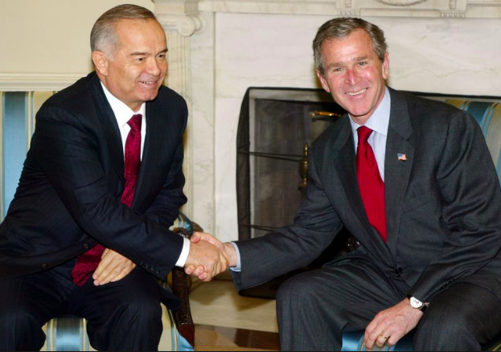
Karimov with GW Bush, 2002

1st Secretary of Uzbek Communist Party 1989-1990
President of Uzbekistan 1991 – his death in 2016

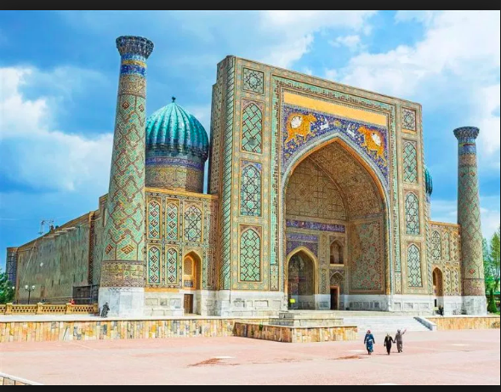
Mosque in Samarkand

“politicized Islam?”

Karimov stoked fears of “Islamist extremists”
Wahhabinism, Saudi influence

NOT the native form of Islam
Moderate**

Exception: Islamic Movement of Uzbekistan

9/11-Bush II Years
Partners in the “War on Terror”
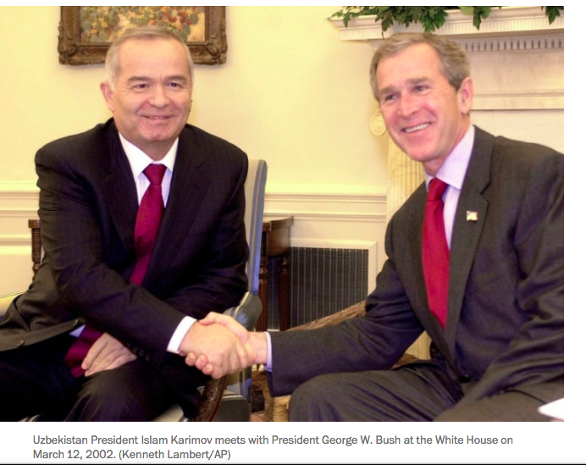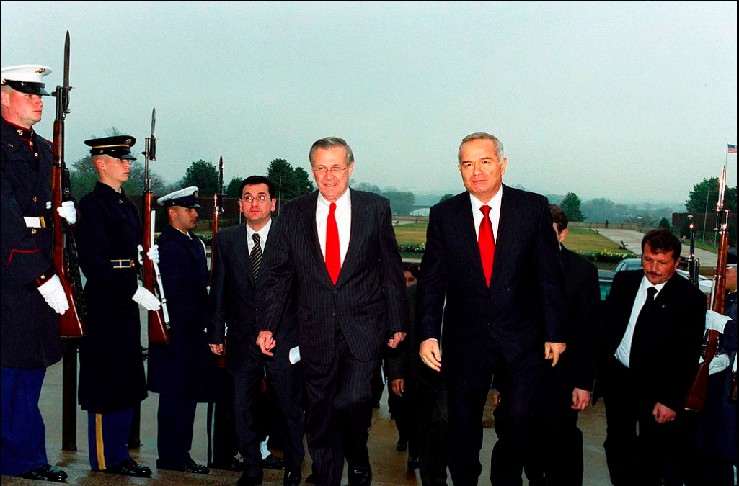
“extraordinary rendition”
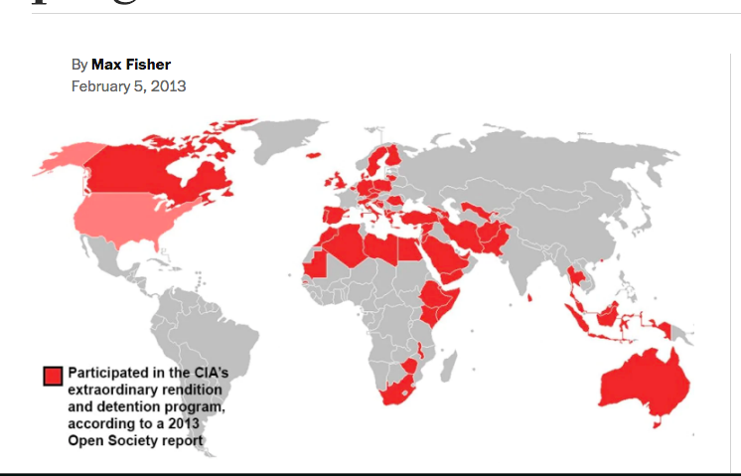

US moved away from Uzbekistan after 2005 Massacre in Andijan

Karimov’s successor
Mirayazov 2016 – present

