Eurasian Politics
Everyday Life in Central Asia

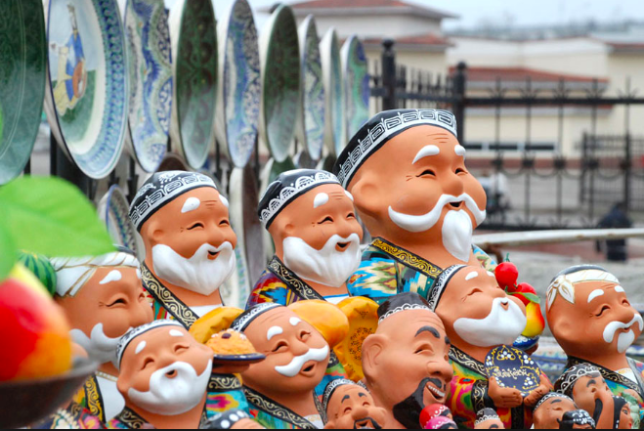
Uzbek miniatures make a comeback

Why this book?

Learn about Central Asia from the ground up

*A radical proposition, esp in POLS that tends to study POLITICAL ELITES
INSTITUTIONS

Anthropology, Political Anthropology

Ethnography

Culture, esp everyday life shows us the foundations of the region

**esp a region we are unfamiliar with

From the Background section of book:

“Events and memories of the distant past continue to weigh heavily on the peoples of Central Asia. Issues of origins, heritage, and lineage pervade everyday life, as several articles in this volume will show.”

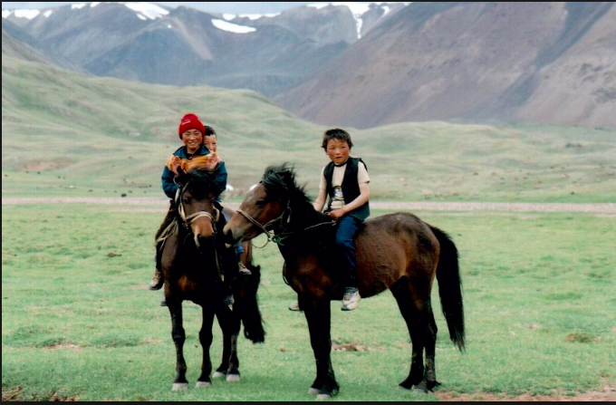
The Kazakh horse

Why? Why might these issues be relatively MORE important in Central Asia than in other regions?

Heritage of great rulers and warriors
Chinggis Khan

Archeology discovers ruins in Russia
Volga River valley

Destroyed by:
Amir Timur (Tamerlane)

Babur
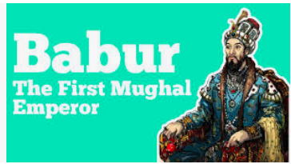
FACTORS that have profoundly shaped the region over time

NOMADISM
Varieties of
Hunter-gatherers
Pastoralists
Herders
Ltd agriculture – seasonal

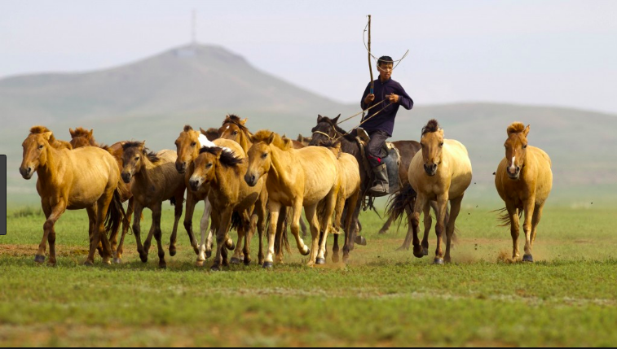
Region often defined by interactions between these pastoralists AND

More sedentary farmers of the south oases
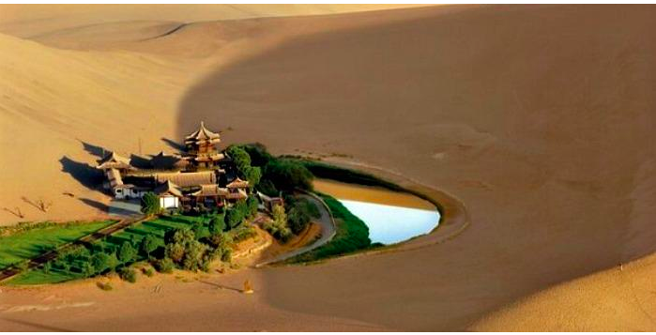

SYMBIOSIS between pastoralists (animals) and farmers (grains)

Traders
Warriors
Relos (wha?)

MIGRATION

DIVERSITY – symbiotic but tenuous
Relations among groups
Trade, economic interdependence

But also INVASION, resource extraction,
Political domination

SYCRETIC process – a two-way street
Conquerers also adapted to societies and cultures they conquered

TurksKazaks, Kyrgyz, Turkmen, Uzbeks

Tajiks Tajiks

Chpt 1 Turks and Tajiks

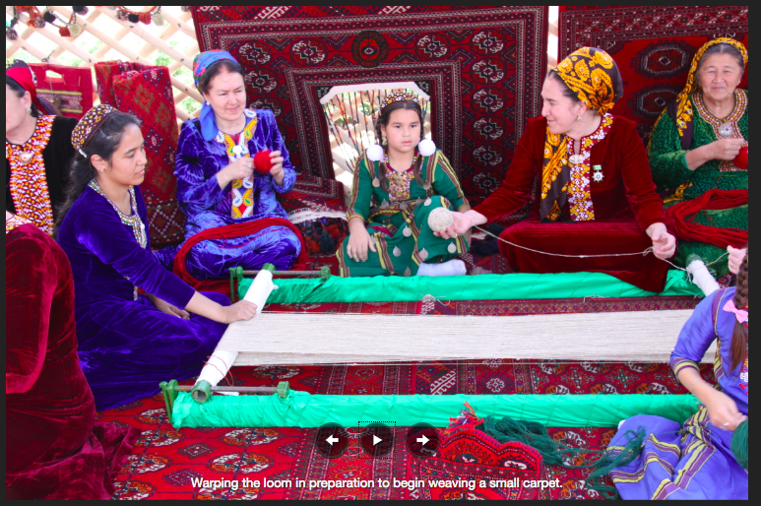
Turkmen women carrying on the tradition of weaving some of the finest wool rugs in the world.

Original inhabitants of C Asia?

People from RUSSIA who moved southward
Around 2000 BCE

Eurasian nomads
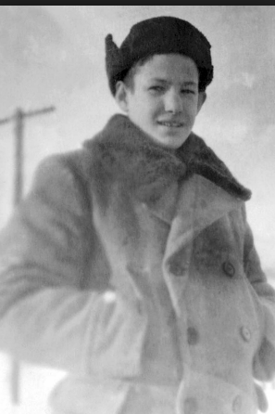

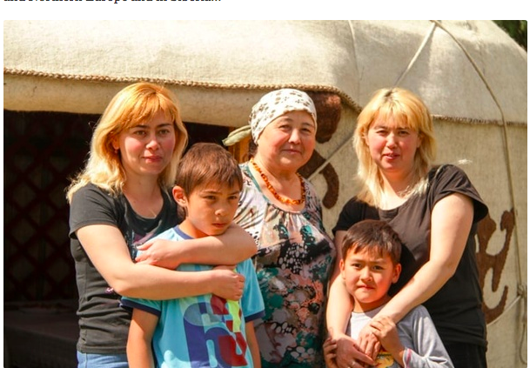
Kyrgyz people

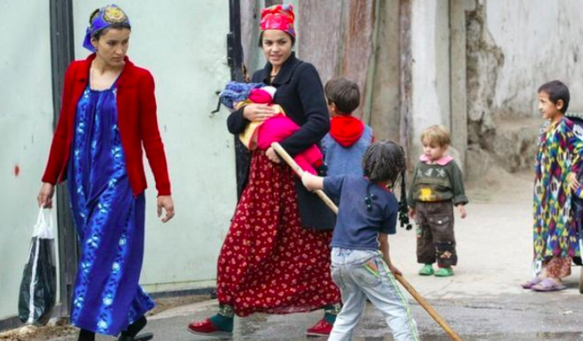
BBC story on banning sale of black clothes for women in Dushanbe

