INST 201 Introduction to International Studies
Europe and the Modern World

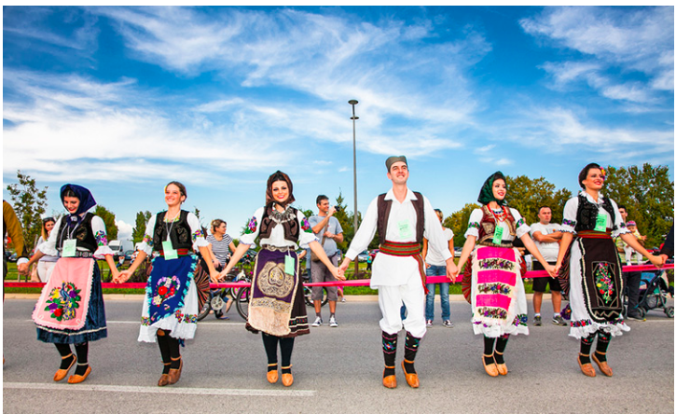
Source: European Commission, Creative Europe

What is Europe?
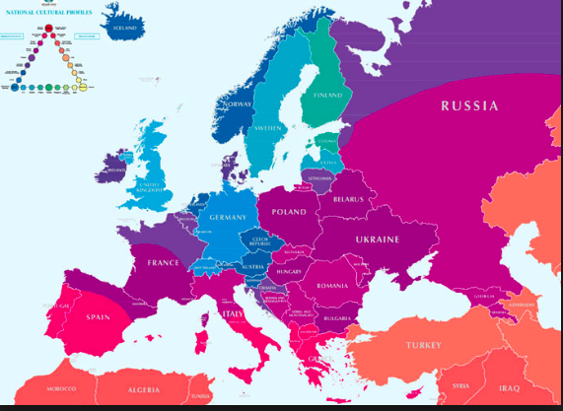

Monarchy, Empire
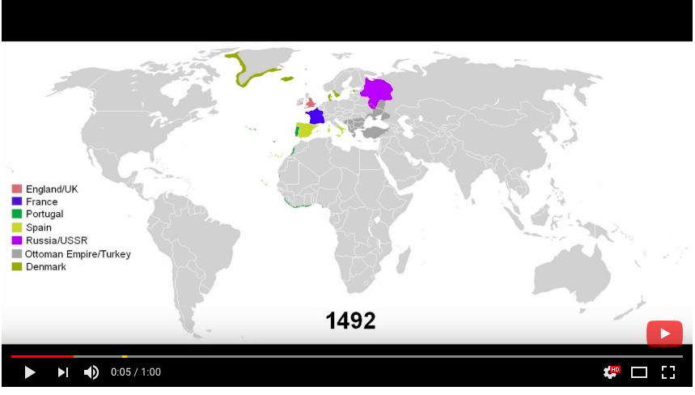

Liberalism/Republicanism
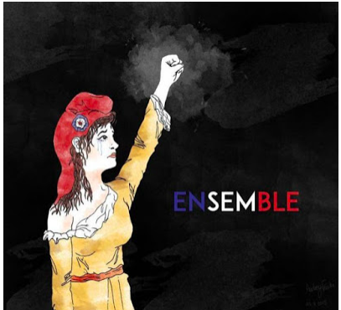
Source: Vagabond blog

Socialism/Social Democracy
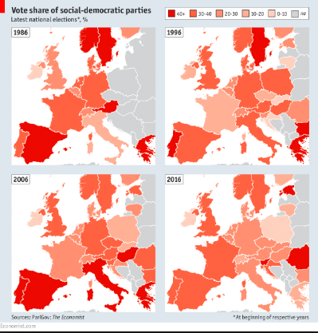
Source: The Economist
Sources of Conflict in Europe: Historically and Today
Between countries: competition for control over local and world resources and territory; religion; nationalism.

Within countries: political ideology; class; religion; ethnicity (nationality).

National Identity
Ethno-nationalism, civic nationalism, political culture
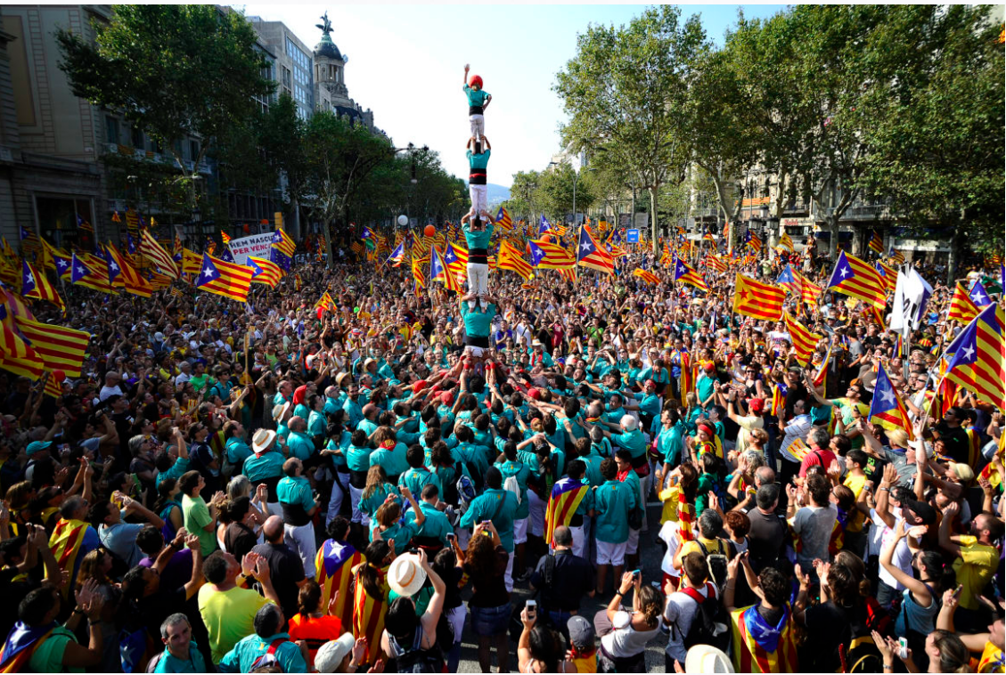

Terrorist Threats to Europe

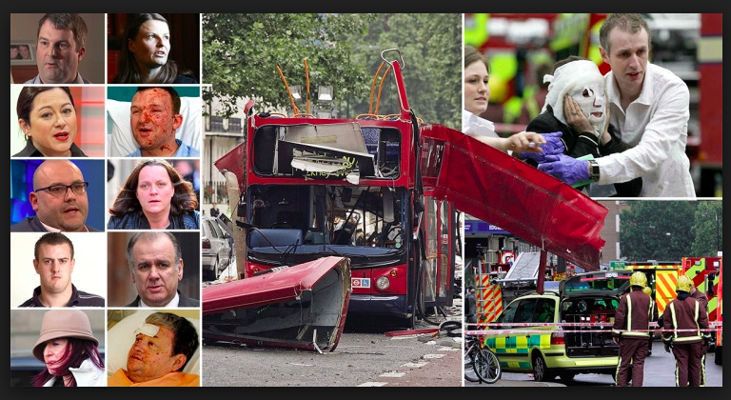
London’s 7-7 (2005) bombing Source: Metro

Data visualization: attacks in Europe over past 45 years
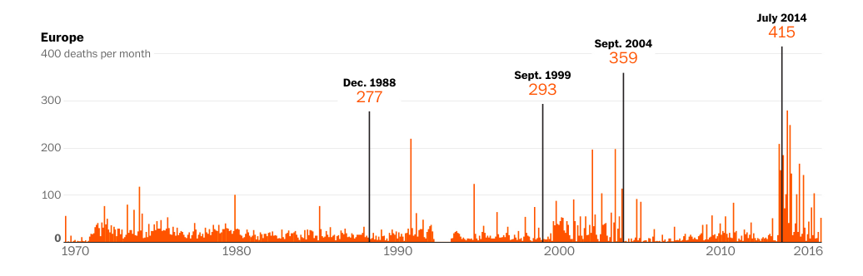

Richard Maher, European Union Institute,

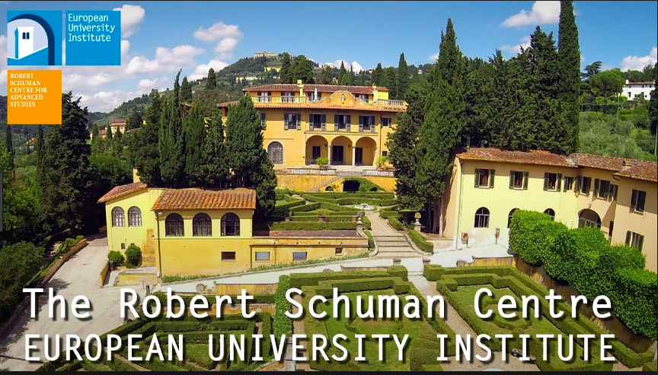

Maher: Why the uptick in terrorism in Europe?
September 15, 2017

Internal/External sources of Terrorism in Europe
Guardian file on Breivik
2018 Film: U – 22 July
Internal/External Threats: A false dichotomy in a post-migration, intercultural world?

Important European IGOs
Human Rights: The Council of Europe
European Integration: EU
European Security: OSCE

Europe in World Affairs
The EU at the UN

The Office of the Quartet
(Wikipedia entry on The Quartet)

NATO

Europe in the Global Economy
The EU at the WTO
OECD
G-7
EU-US Trade: TTIP

