INST 201
Geography Lecture Part II

Components of Geography
Components: Space, Regions, Environment

Spatial patterns, use of space
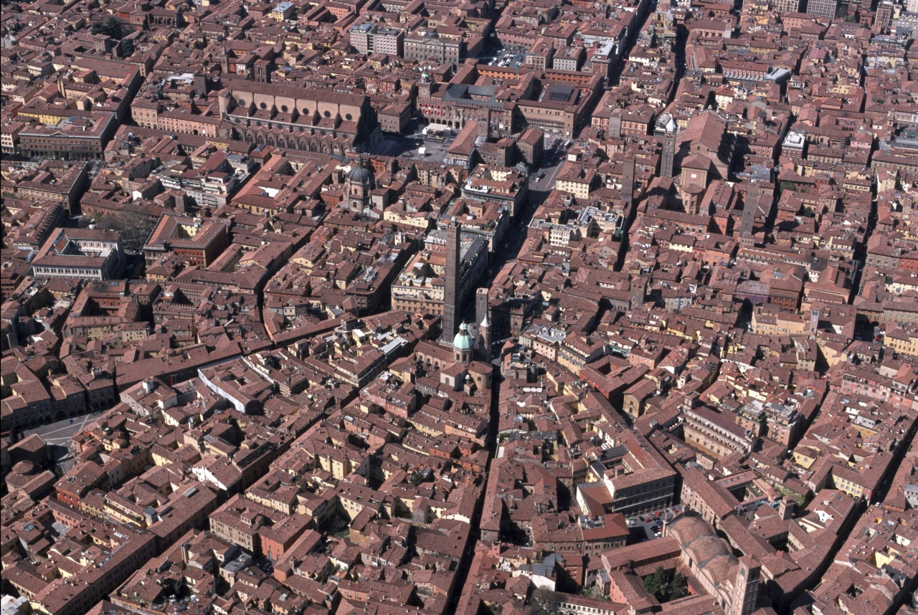
spatial analysis
urban planning and design

Medieval City Layout

Regions –
2 main types: formal and functional

Environment
resources –
how humans interact with their environment
how development, human flourishing, the land’s “carrying capacity” how much population it can sustain

environmental determinism vs human determinism

*best to land somewhere in the middle:
Consider the interactions between environmental opportunities and advantages AND human agency, ingenuity, decision-making, innovation, disease, etc.

Jared Diamond
his Wikipedia entry
his site
Guns, Germs and Steel

Collapse

Maps
GIS (54)
Wikipedia entry for GIS

Software producers:
ESRI
Maptitude/Caliper
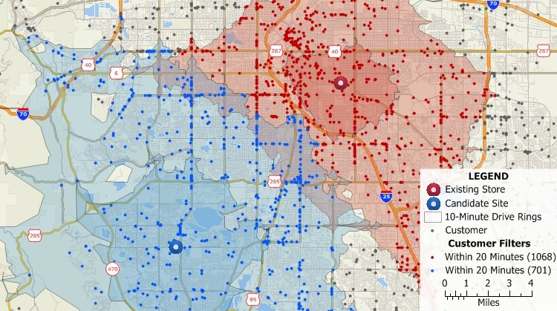

Careers/jobs that rely on GIS, geography skills, analysis (57)
Business, government, education, NGOs/IGOs
Business: analysis of development patterns, population trends to discover new markets and markets that may be “drying up”

Govt: NASA, State Dept, Intelligence (CIA, FBI) rely on geographic analysis – documenting patterns of activity (human, climate, crime, etc).
Spokane County GIS
Spokane City GIS

NGOs/IGOs: UN, World Health Organization (WHO), UN Educational, Scientific, and Cultural Org UNESCO), World Trade Organization (WTO)

Need population projections, analysis of environmental (climate change, natural disasters) and human trends (disease, epidemics, pandemics)
existing and changing patterns of international trade

Lying with maps (56-57) aka Politizing Geography: next time!

