INST 201
Anthropology and Intercultural Relations

Why do people who want to live and work internationally need to be cognizant of culture? Adept at identifying what it is, what it consists of??

What is culture?
what does it consist of?
what does it do?

Some definitions:
“Culture refers to the cumulative deposit of knowledge, experience, beliefs, values, attitudes, meanings, hierarchies, religion, notions of time, roles, spatial relations, concepts of the universe, and material objects and possessions acquired by a group of people in the course of generations through individual and group striving.”

Definition found on Texas A&M Associate Professor Choudhury’s website (click and browse this page and the other two links below)

LiveScience definition and discussion

Wikipedia entry

Culture is symbolic

Culture is shared
Michael Herzfeld’s definition of cultural anthropology (63) as the study of “common sense”

where “common sense” is defined as “that set of unstated assumptions we share with others in our community that we can most rely on in making sense of the world around us.”

What we accept to be true without questioning or analyzing.

**really, a common sensibility

Culture is learned

Culture is adaptive

Levels of Culture
cultural practices
cultural logics
worldview

The insh’allah example in the book (pp. 64-67)
a cultural misunderstanding

Caused by what?

think in terms of the defining characteristics
symbolic, shared, learned, adaptive

and levels of culture
practices, logics, worldview

Developing Expertise in Culture: Understanding Cultural Systems

Considering how culture influences, e.g., politics, economics, life choices, use of space, behavior, etc.

Many disciplines and professions concern themselves with culture

Think of some examples of disciplines and works from these disciplines that depend upon a close reading of culture(s)

The academic discipline most closely associated with the study of cultures is Anthropology
or more specifically “Cultural Anthropology”
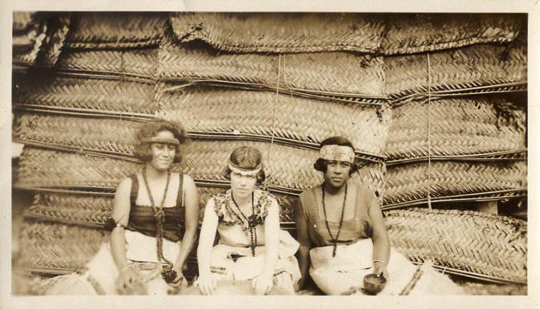

Next time: Intercultural Relations (pp. 77-88)

