Comparative European Politics

East is East (1999): A window into the lives of Pakistani and “British-Pakistani” experiences
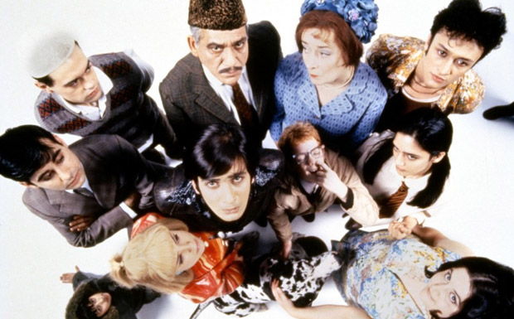

Trailer

Mix

George (played by recently deceased Om Puri), Pakistani, Muslim immigrant (left his Pakistani wife behind). Migrates to England in 1937; where he meets and marries his wife, Ella (English woman)
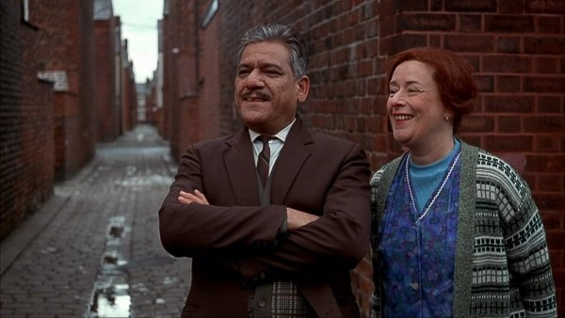

Together, they have 5 sons and a daughter (one deceased son – not actually dead, just gay).

Living in Salford, Manchester, solidly middle class (working class) area of brick row homes. They own/run a fish n’chips shop. (Mrs. Padmore!! from Downton works at their shop and is family friend!)

Opening scene – kids run from corpus Christi parade to hide from Dad their participation
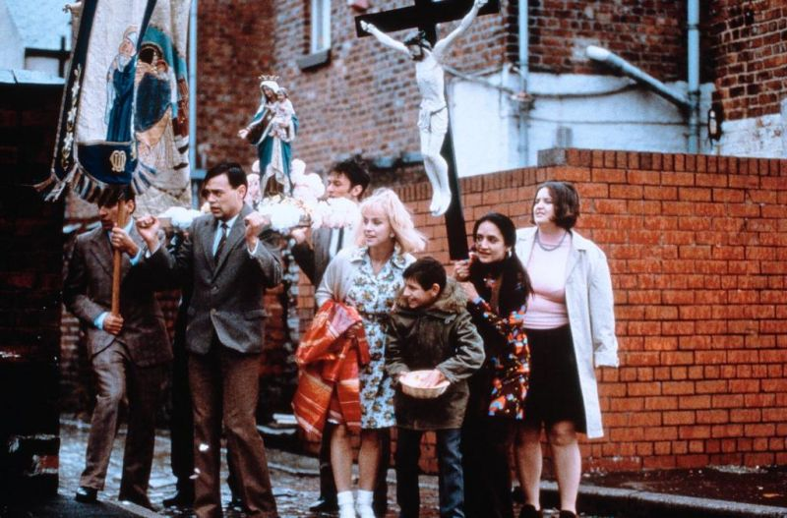

Kids becoming more and more “Anglicized” integrated? assimilated?
(what’s the difference among these words?)

Dressing in traditional garb – kids feel awkward, silly in them.
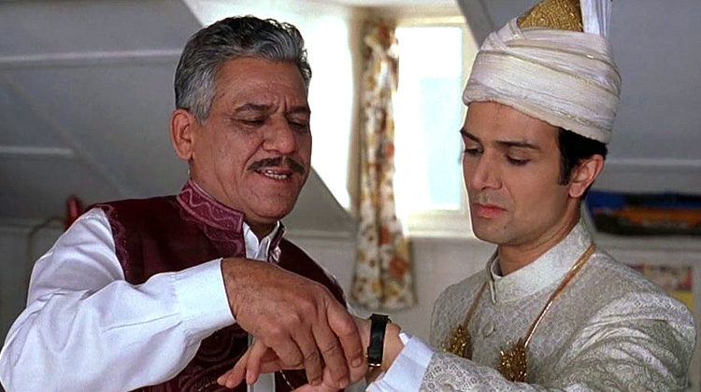
Why are they wearing them?

Oldest brother getting engaged; he refuses to eat rice cake, runs from hall, yelling that he can’t do it. The shame for George; talking in mosque with friend.

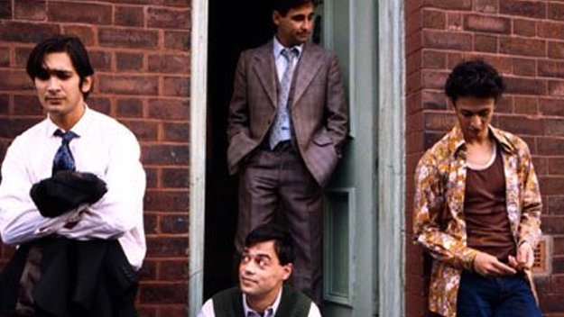
Next oldest son, Tariq, making out with neighbor girl. Friend says, “your grand-dad will go ballistic if he finds out your courting a Paki.” [contextualize: relations between hegemonic, English identity and xenophobic othering of S Asians.]

George, holding radio up to ear to get news of Pakistan (internet! cable tv not!)

Bachelor party at auto shop where Abdul works; “you know he doesn’t drink.” (a problem of assimilability?)

Other culture clashes/dilemmas: circumcision; smoked pork sausages; men kissing men;

Bradford (sign: Bradistan); arrange marriage of two sons.

(Splice of Pakistani film – love story idyll. Playing at cinema owned by relative.)

Tariq and older brother Abdul (Arthur) sneak out to club. Older brother can’t believe his eyes. Dancing. (Jimmy Cliff! reggae in its infancy; becoming popular in “the West” – UK, Germany then US.)

Enoch Powell
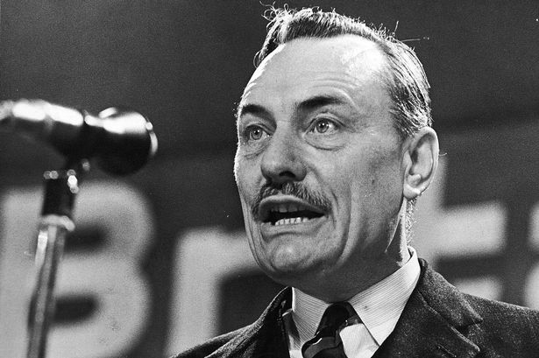
Shown on TV making speech about “repatriation.” Posters around about him speaking about immigration. (full text of “Rivers of Blood” speech here)

Climax and denouement:
violence against Ella. Beats her, kicks her, calling her a bloody bitch for trying to protect/defend Tariq for not wanting to marry on of the Shah’s daughters.

What is this conflict really about? What does it symbolize?

conflict of old and new ways; Pakistani/English; traditional/modern and secular; patriarchy v egalitarian marriage; hierarchical family systems v fluid ones

Denouement: does Ella leave? does anyone leave?

Why? What are we left to ponder, believe happens next???

I think: no easy resolution. Things don’t just change overnight. Tariq/blonde girl/Meena’s
Represent a generation living in world between – navigating between traditional and English societies; one foot in each world – older generation can’t change, can’t adapt, get its footing, accept it.

Sequel: West is West (2010)
YouTube version

