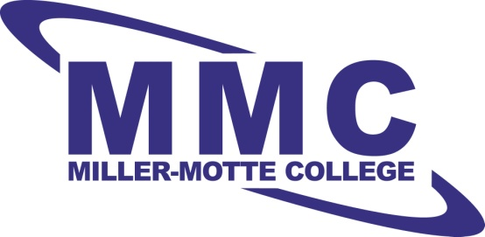

Bridgett Hayes
Student Services Coordinator
Miller-Motte College
3901 Capitol Blvd Raleigh NC Suite 151
Raleigh NC 27604
919-723-2823 Direct
To: Hiring Manager
Angela Smith is an IT student at Miller-Motte College, and I have experienced the pleasure of working with her on numerous occasions for various projects. She is a motivated self-starter with a drive to succeed despite of any unforeseen obstacles. Angela is punctual, ethical, dependable, and capable of learning in a fast-paced environment.
Her expertise in data processing and the IT field could prove extremely valuable to the Help Desk Technician position. Angela’s strengths includes: attention to detail, the ability to work with complex technology, and the ability to work on an organized team or independently. I highly recommend Angela Smith for the Help Desk Technician position. Please feel free to contact me via email or direct phone should you have further questions. Thank you for giving her this important opportunity.

Sincerely,

Bridgett Hayes

Bridgett Hayes

