Comparative European Politics
Bend It Like Beckham (2002)

Main character: Jess (Jessminder) dreams of playing professional football; pulled between her Sikh family’s traditional wishes for her daughters and her dreams, the opportunities that living in more gender equal society like the UK present.
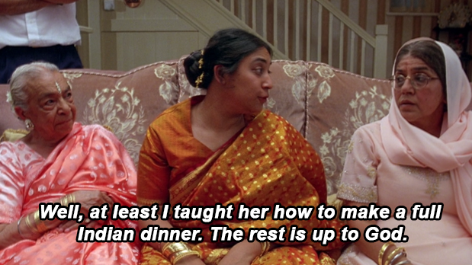
English girl, Jules, also pressured by her mum to be more “feminine.”

Invited to come out to Hounslow Harriers girls club team; first obstacle: she has to wear shorts; scarred leg – burned. Also taboo in her culture for girls/women to show their legs. (observed by mother in park in shorts AND being handled by one of her guy friends she plays with)

Mother tells her she was married when she was her age! (16?)

“Look how dark you’ve become spending all that time playing in the sun!”
“It was ok when you were young.”
“That’s it: no more football.”

She defies them, but ultimately gets in much greater trouble when being seen with Jules leads to her sister’s broken engagement; gets busted after traveling to Hamburg with the team.

[Sexuality. Jules’s mother is devastated because she incorrectly assumes that she’s in love with Jess. The point: every culture, every family has its taboos, its expectations for its children.]

Jess’s friend “Tony” is Indian AND gay.

Sneaks out again for game; dad at game; girl calls her a Paki and she gets a red card even thought she was attacked. Her coach is Irish and in love with Jess. (Jess’s dad catches them hugging.)

Sister’s engagement is back on! Wedding slated for same day as championship game, when American scout will be there.

Her father ultimately gives her permission to attend the game so that she can be happy at her sister’s wedding.

The wedding: a wonderful example of the intersection of secular, British society and traditional Punjabi traditions (with elements of Bollywood).
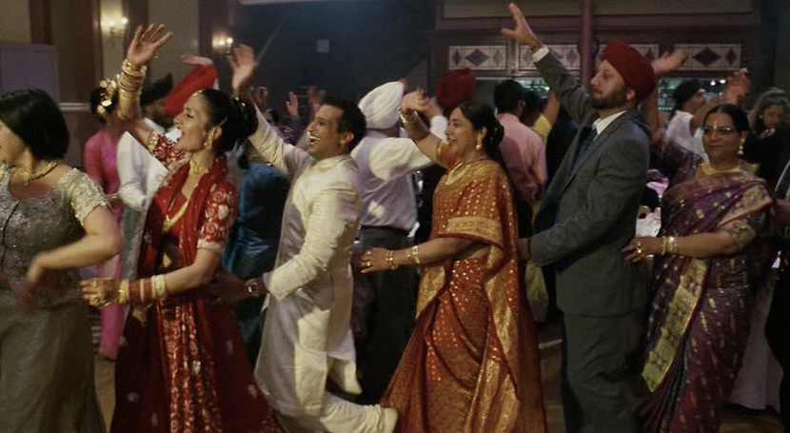

Jess’s hallucination on the pitch before she shoots penalty shot to win the game – she envisions her Indian women relatives.

Sweet scene after match of the girls on her team dressing Jess in her sari…

The many faces of Jess. An integration story.

yes, it’s a cheesy chick flick version of an immigrant story but it’s also a representation of the many successful examples of “race relations” and integration in the UK.

It’s not all what we see in the news today, e.g., Islamophobia, Pole bashing, anti-immigration.

Last scene: dad and Joe playing cricket together.

