Comparative European Politics
Notes on Le Havre

What is different about the film stylistically from American made films? What is the director trying to do with the set design, pacing, style of the movie?

Slower pace, more theatrical style
Set design – deliberately minimalist, pared down, nostaligic
Color scheme – to evoke late 50s, early 60s
“modernity” (e.g., Café/Bar called “Le Moderne”)
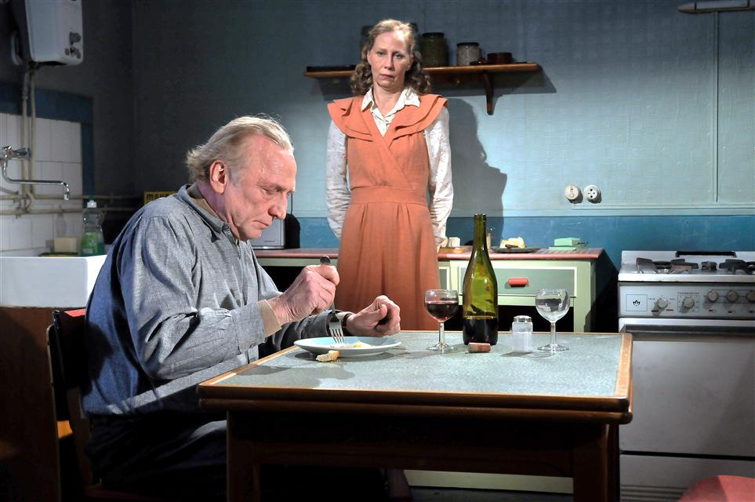

Director is saying how France/Europe is caught in the 1960s in terms of its approach to immigration/migration/refugees/asylum seekers

Has policy of national protection/policing (the ninja turtle guys) treating people like criminals; putting them in detention centers; deporting them

To what end?
We see Idrissa at end of film sailing to the UK to be reunited with his mother – but how? For how long? Revolving door; passing the buck; ineffective
e.g. example of Chang; buying his identity papers: “There are more birth certificates in the Mediterranean than fish.”

Symbolism
Parallel of illness (cancerous tumor) of Marx’s wife
With the cancer that is the problem of immigration on the body politique/the Republic

Both are miraculously “cured” – she by “modern” medicine; the immigration problem by moving people along to another country

Note also that she went to the hospital, was treated, no talk of how they were going to pay for it!!

Class status/relations
Lower working class – very poor; scraping by; living hand to mouth as exemplified by Marx, a lowly shoe-shiner; in same economic status as illegals working in the semi-official economy; manager of the the chi-chi shoe shop keeps shooing him away from his sidewalk as a disgrace to his bourgeois sensibilities, his customers
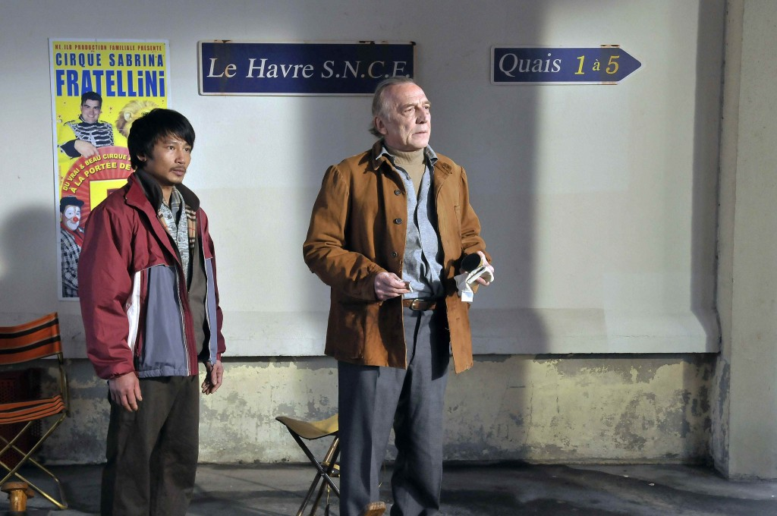

Also, notice the solidarity between him and recent (illegal) immigrant now with legal status based on false identity “Chang” who is really from Vietnam

Class/neighborhood solidarity
Marx’s neighbors deeply embedded in system of reciprocity and trust (except for the one neighbor who is informing on him)

The others rally around him and Idrissa; care for them in the absence of Artletty (Marx’s wife) and also are secretly visiting and supporting Arletty through her treatment/hospitalization
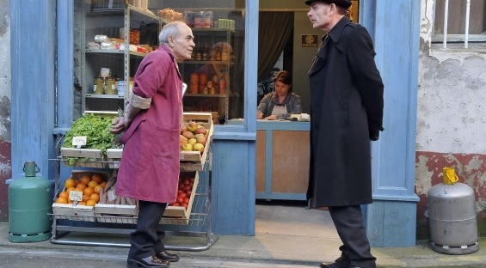

They put on a “trendy benefit concert” to pay for Idrissa’s “passage” to the UK
Note: this is also a criticism of the state’s ineptitude; civil society has to solve the problem

The State
Cold, impersonal
Treats migrants, refugees as criminals
Marx has to lie, pass himself of as a relative, threaten the civil servant with the “Civil Code” to get to see Idrissa’s grandfather in detention
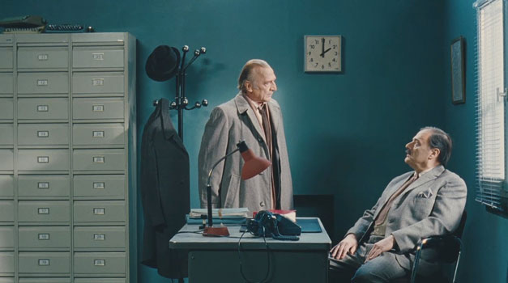

Depiction of French Culture
Obsession with regionalism, food, wine, aperitifs

