Global Gender Regimes
Women in Politics

Measures of women’s political behavior
Interest in politics
Voluntarism, work in non-profit sector
Voting in US
Turnout
Gender Gap
Gender Gap in 2016 US Presidential Election

Best site for data on Women in US Politics: See Rutgers Center for American Women in Politics

Running for office
Attaining political office
If women have ever attained a nation’s highest
Political offices

US Success Stories

First ever major party presidential nominee
Former Secretary of State
Former Senator of NY
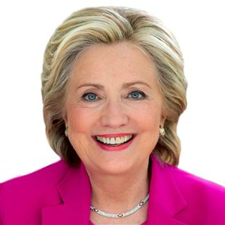

One-time Speaker of the House and current Congresswoman Nancy Pelosi (D-CA)
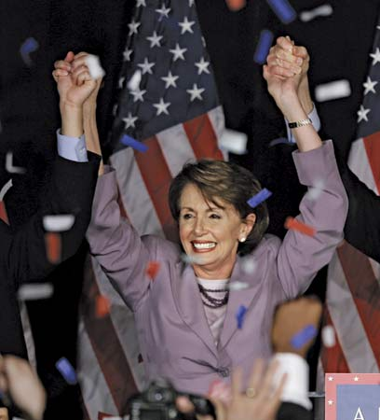

Former WA State Governor Christine Gregoire (GU Law Alumna)
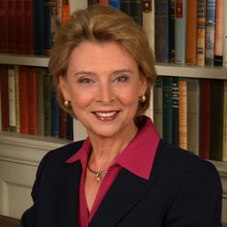

Congressperson Cathy McMorris Rodgers (R-Spokane)
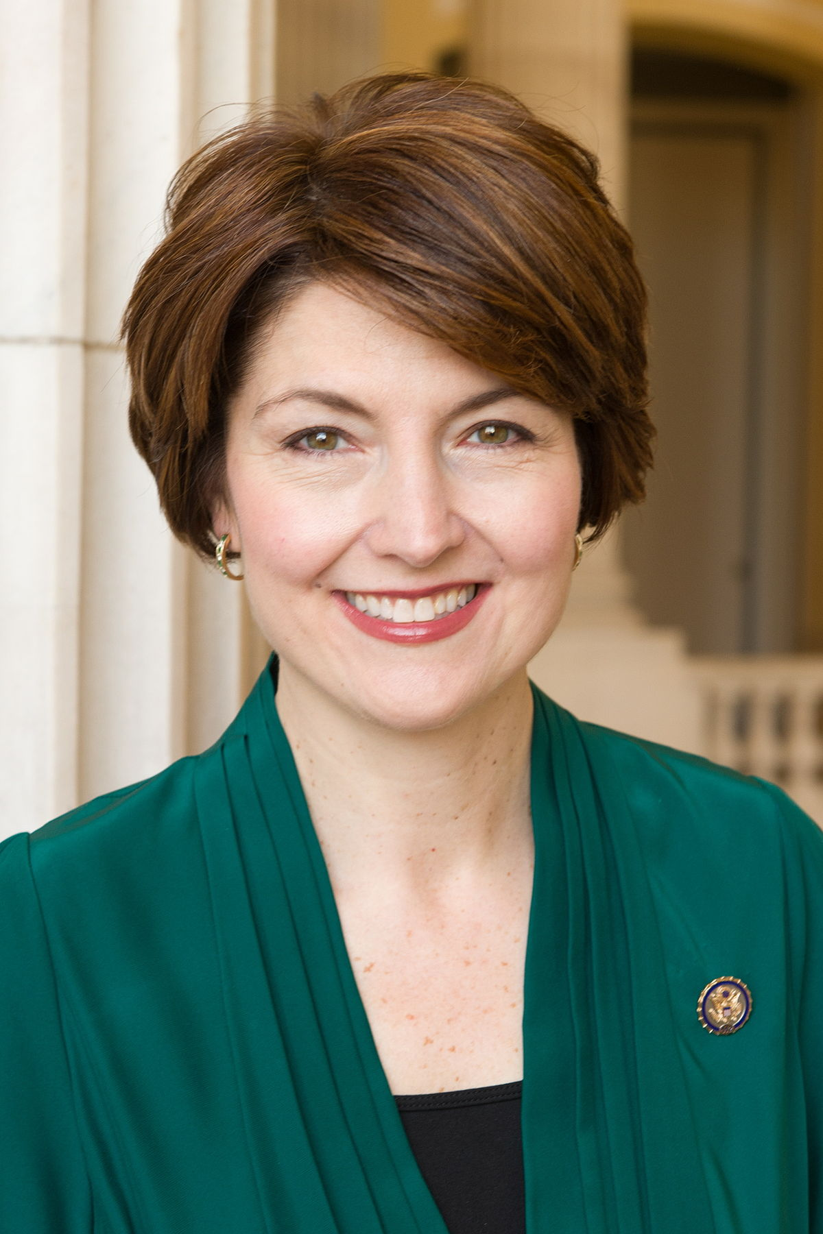

International Comparisons of Women in Politics
In comparative politics, most common measure used to gauge and compare women’s political power is:

Proportion of women serving in parliaments,
Typically the lower/only house

This data is compiled by the Women’s Inter-Parliamentary Union
See What We Do…Women in Politics
Current and Regional Averages
Data by Country

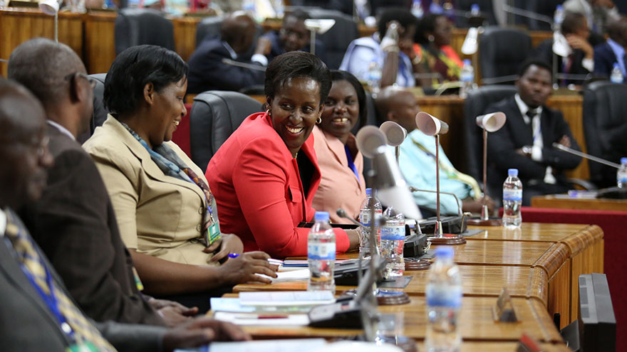
The Rwandan Parliament is the only parliament in the world where women outnumber men
NPR/Invisibilia story on

Where does the US rank globally?
101/190 countries
19.3% of the lower house as of 2016 elections
Vox article on (source of graphic below)

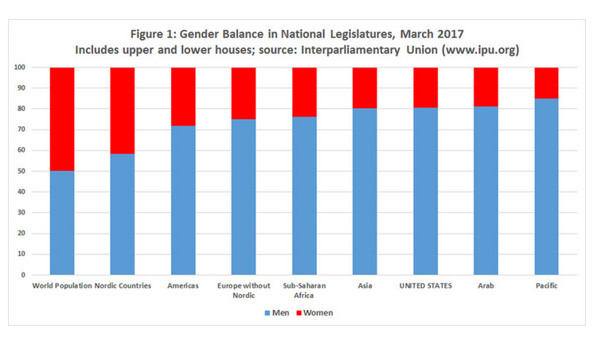

UN Global Map 2017

Why? Why, given all the opportunities American women have are there not more women in Congress, women presidents?

Institutional Factors
Presidential vs. parliamentary systems

Former British PM Margaret Thatcher
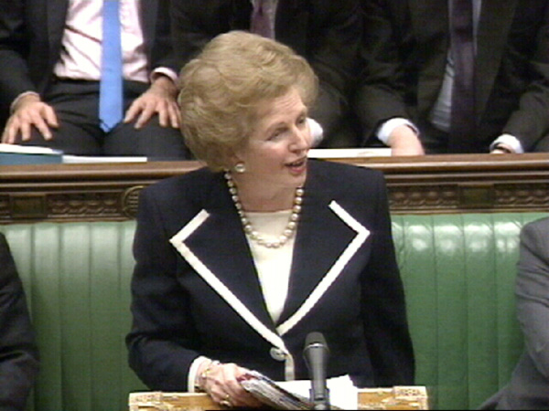

German Chancellor Angela Merkel
Longest serving chancellor in post-war Germany and of all current democracies
2015 Time magazine Person of the Year
The only world leader to consistently “fact shame” President Trump
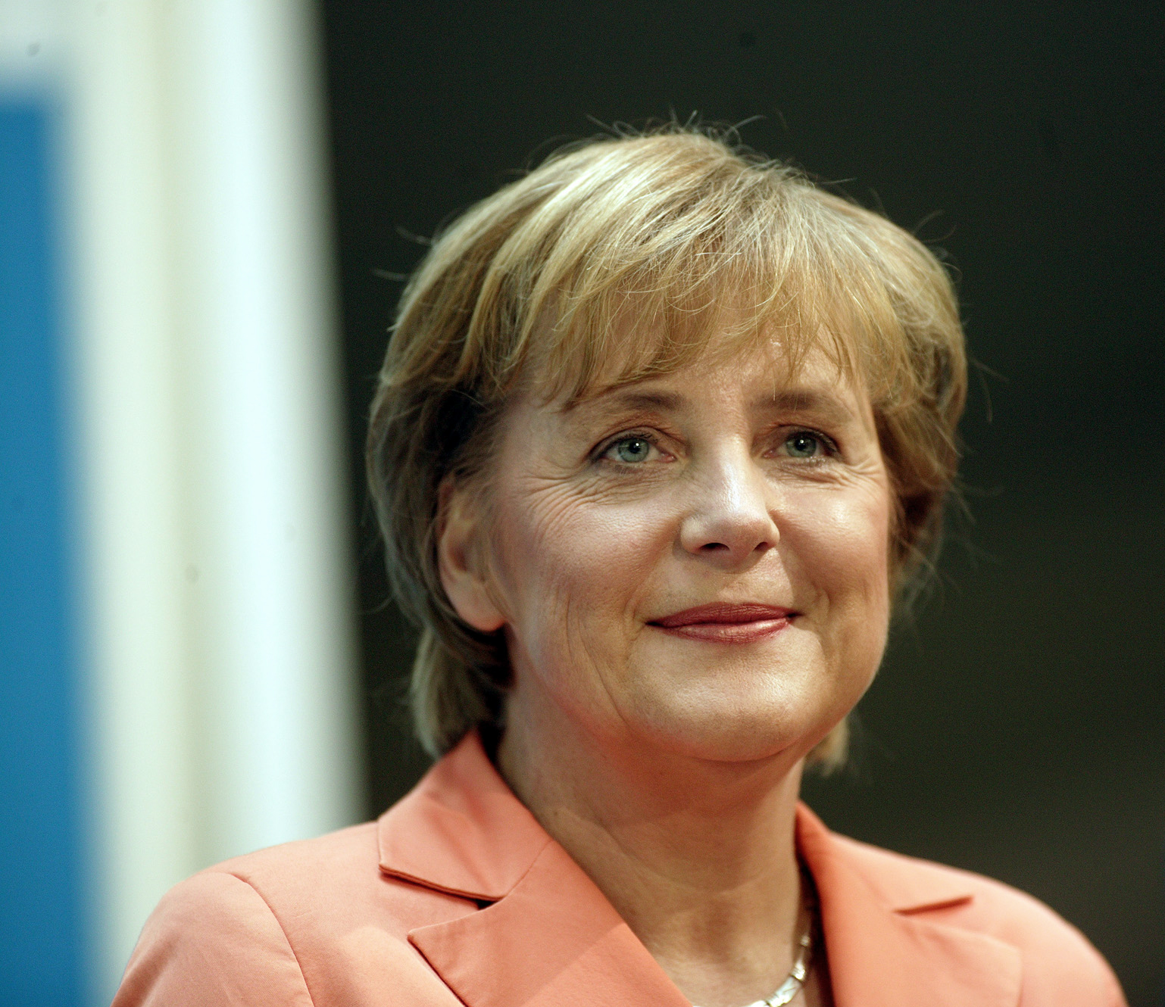

Means of improving women’s representation in parliaments
Quotas/seats reserved for women – pros and cons?
Party based quotas/incentives

Why women don’t run
Politico article

Elder Article
Tests Sociological Factors (interest in politics, feelings of efficacy, gender role expectations, role models)
vs Structural Factors (women’s relative absence in professions leading to careers in politics)
vs Situational (disproportionate time/energy spent on child-rearing, family)

Finds that both Sociological and SITUATIONAL FACTORS even ANTICIPATING these responsibilities most depresses women’s rate of candidacy

