Comparative European Politics
Discussion questions on The Invisibles
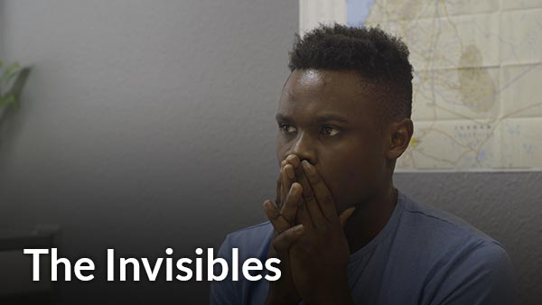

Describe the facilities and processes you see in the film.

What do the facilities – offices, barracks, furniture, clothing, bedding look like?

What questions, metrics, documents do the workers at the facility collect on the people at the facility?

What languages do the people and the workers at the German facilities speak?

Where are the people from? Where have they been living? Describe two of their migratory paths to Germany.

Why did they leave their countries of origin?

What do you think of the way the people are treated by the Germans? What are they doing well? What could they do better?

