Comparative European Politics
Notes on The Ox
Swedish Political History and Culture
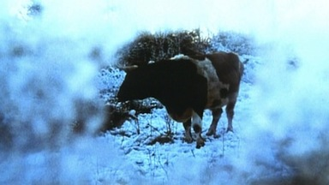

The Famine of 1866-68
How did Swedes survive this famine?

How have they survived since the Middle Ages?
Agriculture (Industry)
Self-Reliance and hard work (Community and Social Solidarity)
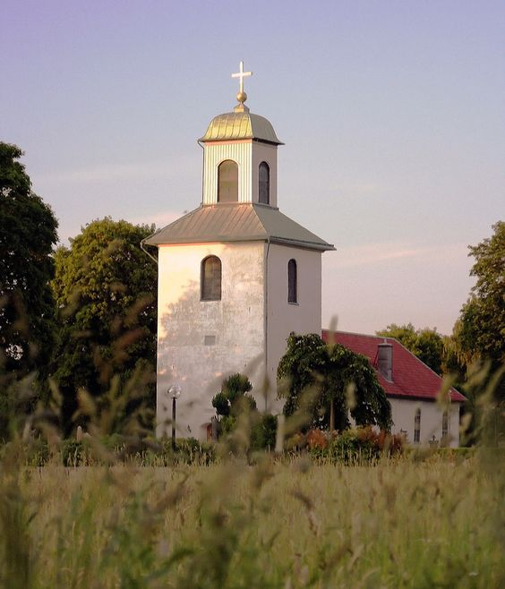

Harsh climate; harsh justice
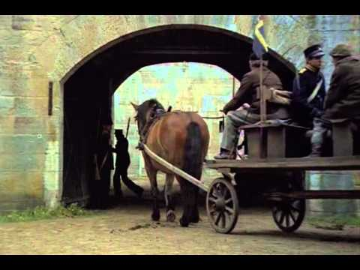

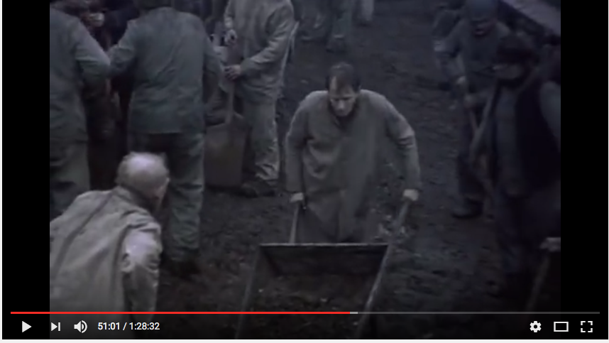

Swedish Cinema, Scandinavian television, literature (e.g. Stieg Larsson Girl with the Dragon Tattoo triology)
Tone?
Themes?

DIRECTOR: Bergman
See themes listed in Wikipedia

CINEMATOGRAPHER/DIRECTOR: Sven Nykvist

ACTORS: Max van Sydow
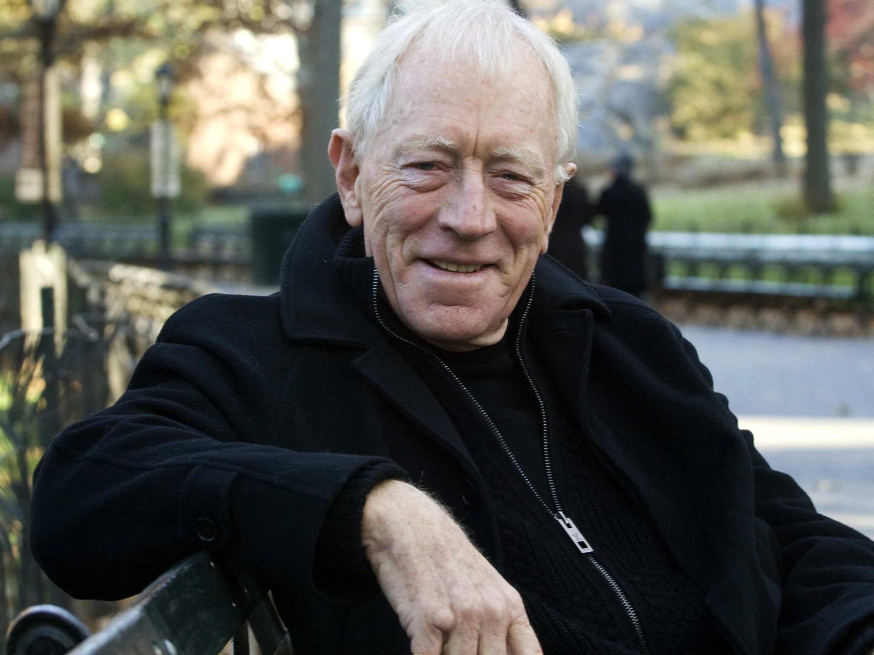

Liv Ullman

Stellan Skarsgaard

