Comparative European Politics
German Political Culture in Film
The People vs. Fritz Bauer

The “Nazi hunter” – pursuer of justice, indicter of the German people who participated in the Holocaust, made the Reich run

Fritz Bauer – wiki

The Auschwitz trials - wiki

Fritz Bauer – Independent news story on
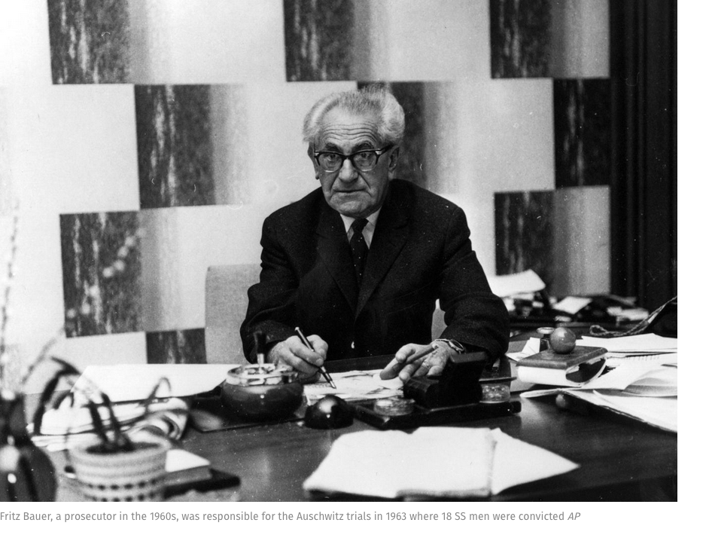

Lore
a compelling story about Germans’ actions and beliefs during the Reich and the harrowing aftermath
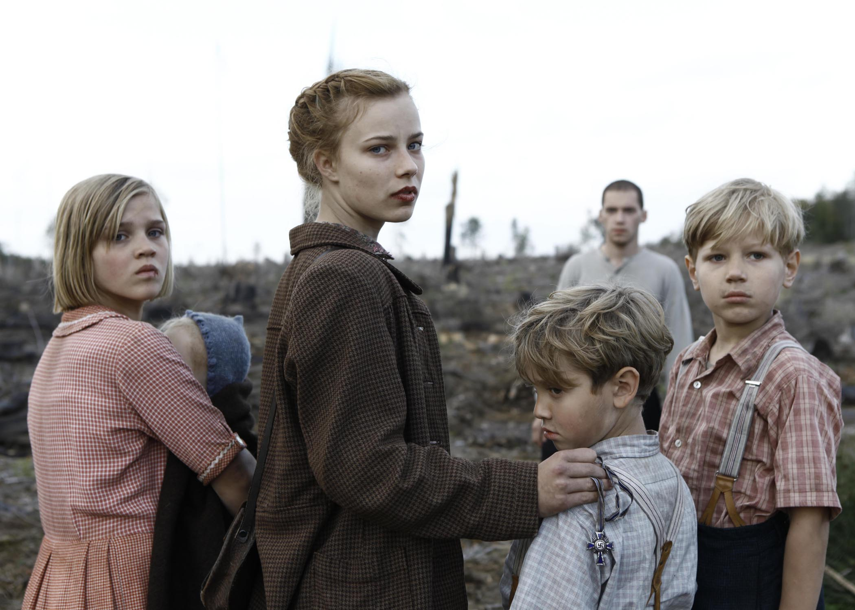
children, women, everyone suffered, tortured, killed
did things to survive
the suffering and humiliation of displaced people
the meting out of “justice”

On the East Germany experience (and the reunification treatment of former Gestapo, informers)
The Lives of Others

