How often do you go rock climbing?

Alex: Hi, guys. What’s up?

Lori: Nothing much. Where are your rollerblades?

Alex: I don’t have rollerblades. I hate _____________________.

Lori: You do? So why are you here?
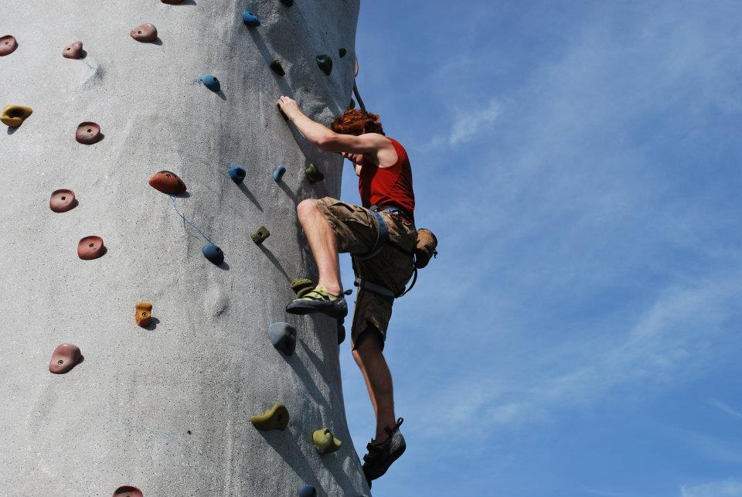
Alex: Well, I ___________ watching you guys.

Lori: Sure you do. What sport are you into?

Alex: ________________________.

Karen: Seriously? _____________________ do you go rock climbing?

Alex: Once a week – at the Sports Club.

Diane: That’s just wall climbing, Alex.

Alex: At least I’m not a _________________. By the way, where’s Joe?

Diane: _______________.

Alex: At home, of course. Let’s call him and see if he wants to join us.

Diane: Don’t even try, Alex. Joe would rather ___________ than play sports.
Alex: Brr. It’s cold. I think I’d rather __________________in this cold weather. See you.

