Comparative European Politics
Swedish Political Culture
A Man Called Ove
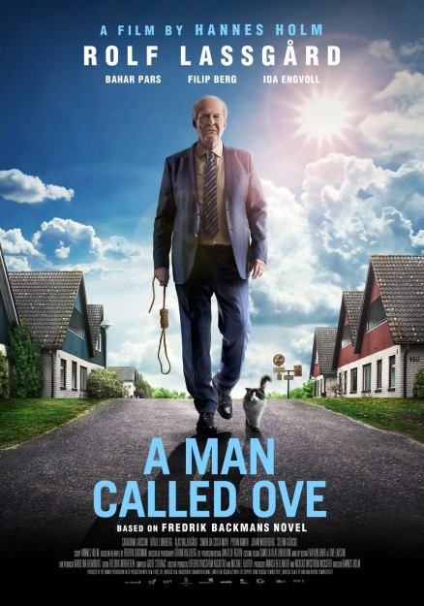
Trailer
Plot summary

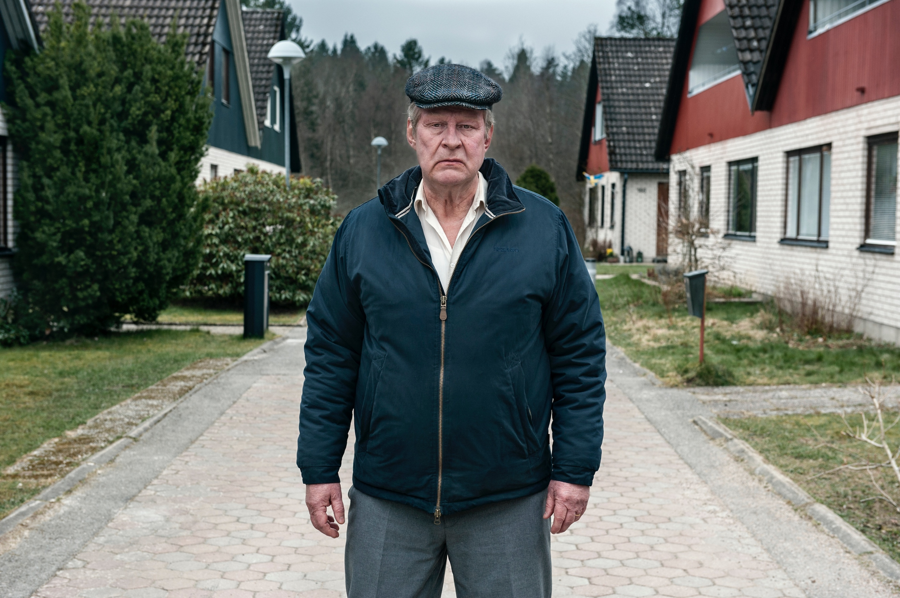

Why is Ove so unhappy? (or is he?)
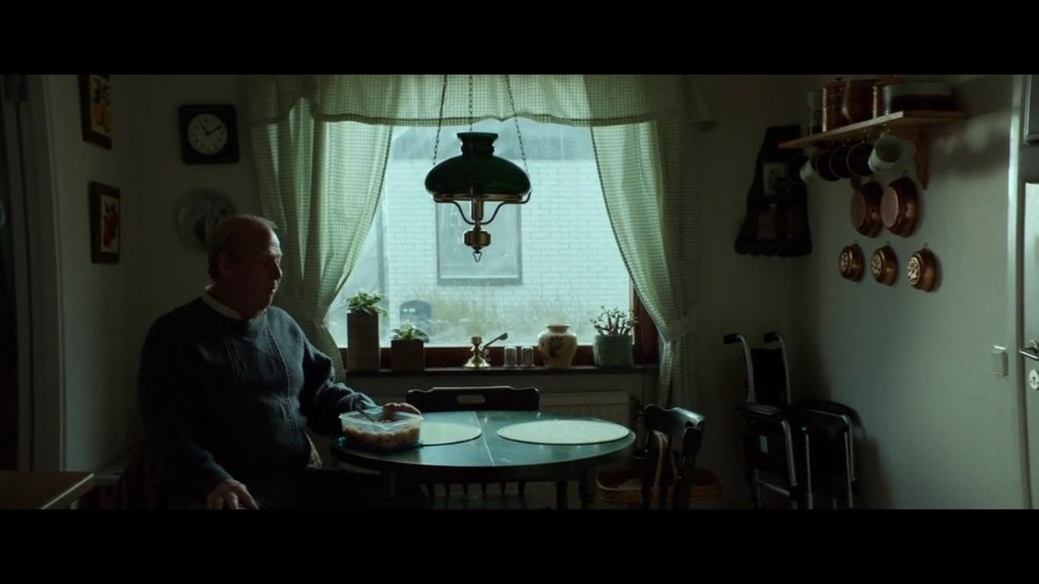

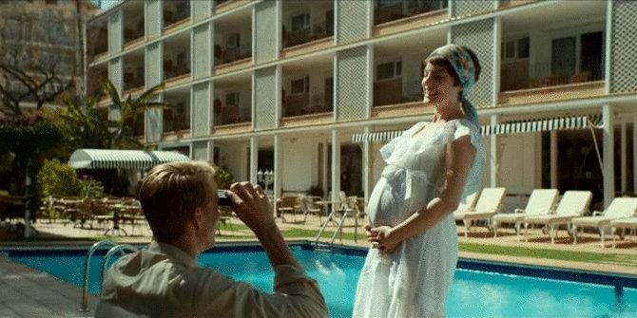

What larger story about Europe from mid-century to the present is told through Ove’s life?

What story/stories about LIFE IN GENERAL are told by the film?

What story about Swedish political culture is told in the film??

