Italy in Film
Sacro Gra, Fuoccoamare, My Way
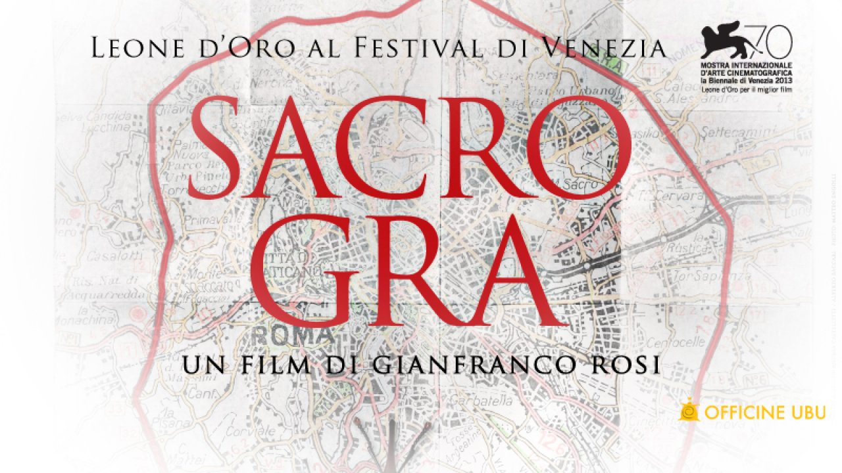

GRA=Grande Raccordo Anulare (The Great Ring Road)
Trailer

Describe some of the people we see in the film – what is their relationship to each other? What do they do for work? How do they live?

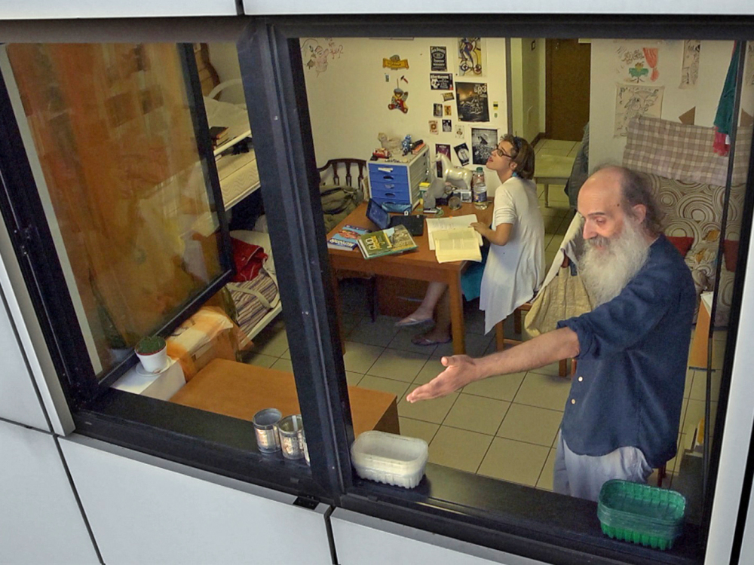

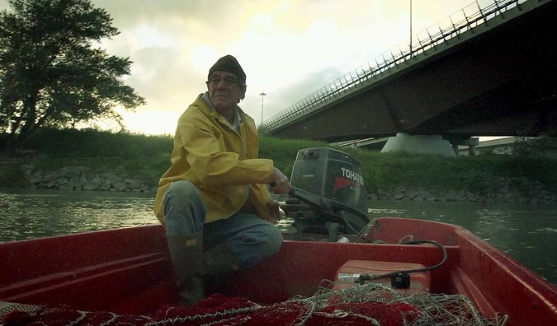

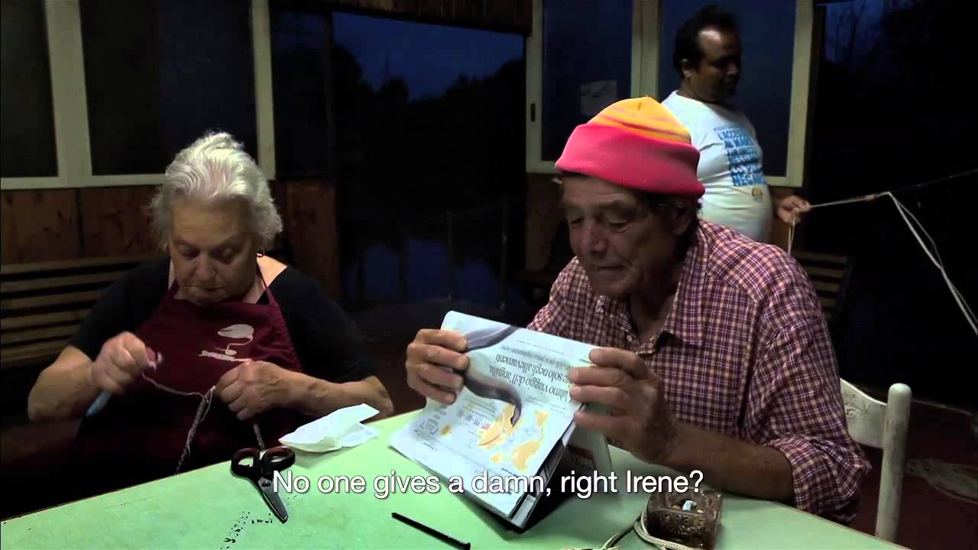

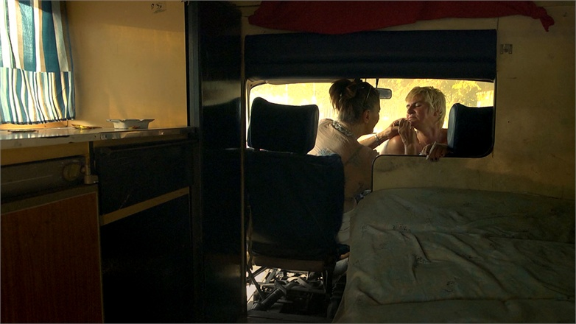

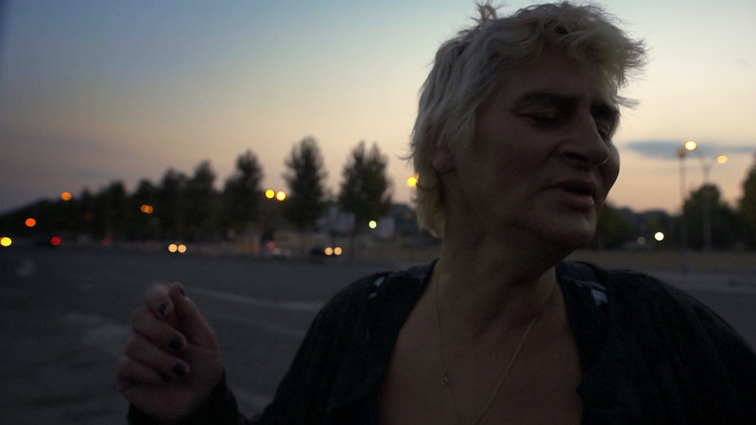

What is Sacro Gra about? What’s the point????

What is the pace of the film? Why???

Fuoccoamare: Fire at Sea (2016)

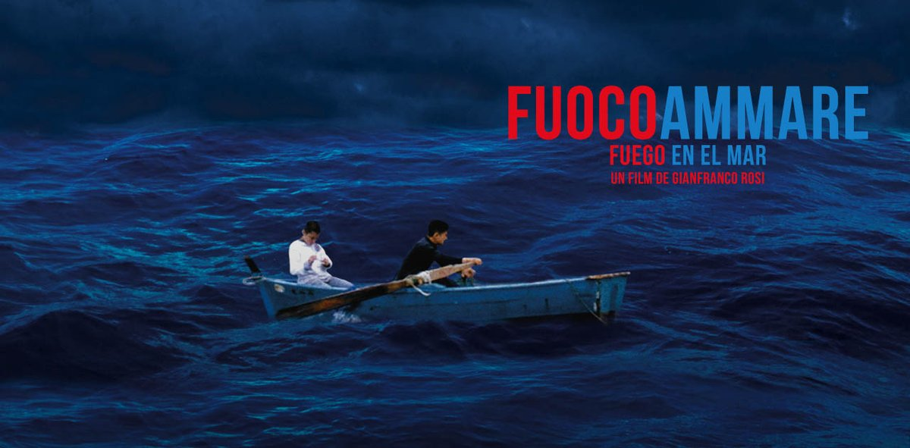

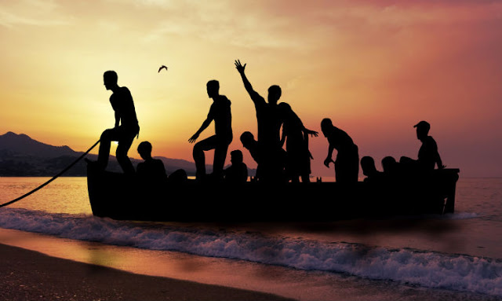

Trailer

Describe the style of film making
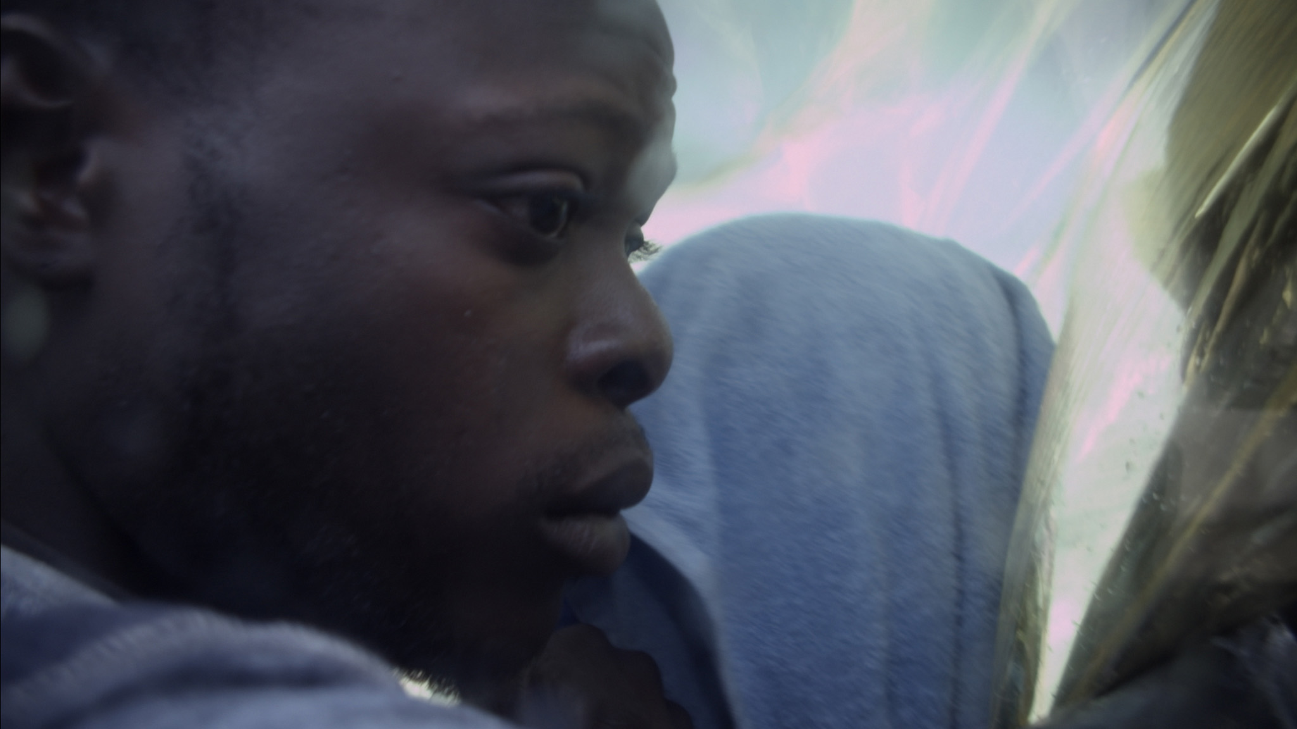

What devices, effects does the film maker use?
IndieWire story on

What is the effect of these devices, effects? Why did he chose them?

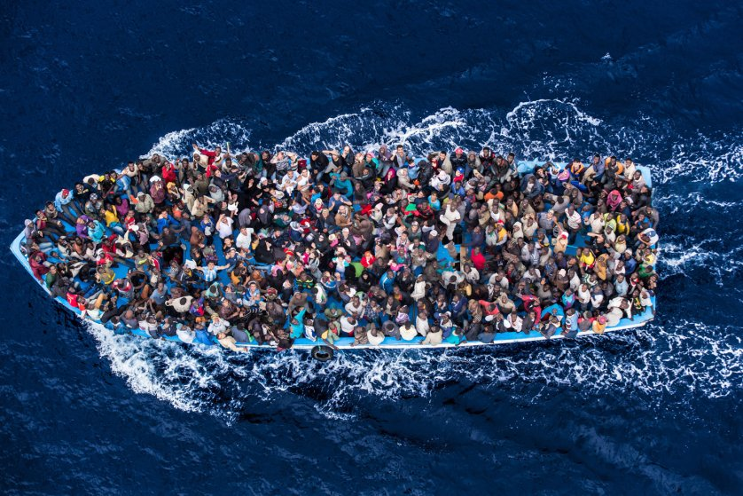

Director of both Sacro Gra and Fuoccoamare: Gianfranco Rosi
Guardian interview

jumping back and forth among vignettes, storylines, people

sound

helicopter, motorbike SO loud

boys, conversation, music, news: medium

images of people after rescue through plastic: silent
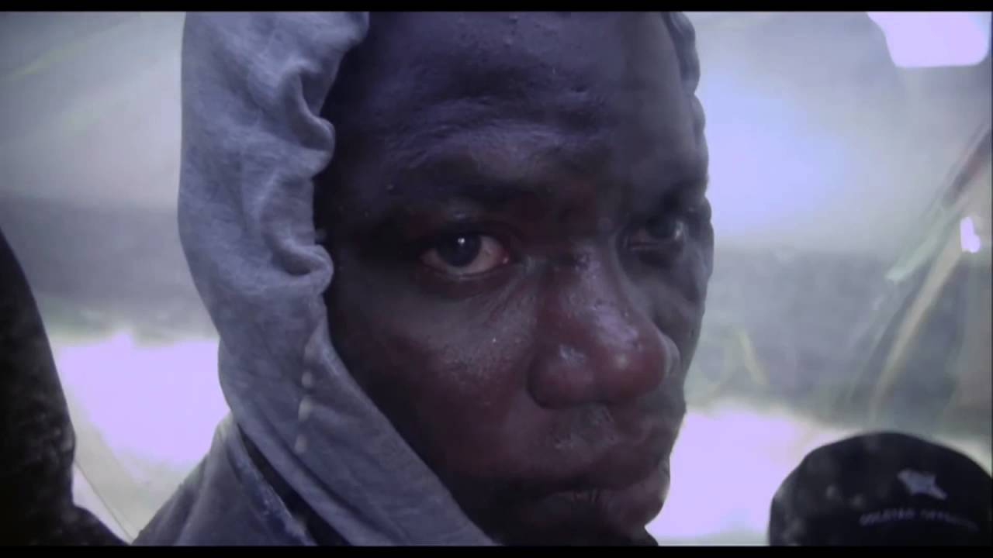

How do the Italians you see in the film treat the refugees?

What the take-away?

