The New Europe
Discussion of The Invisibles
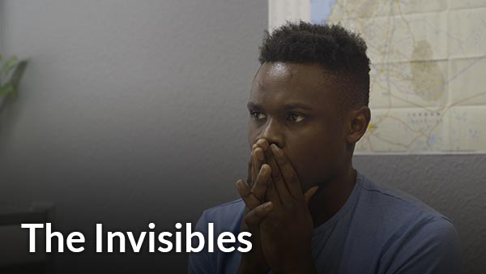

Describe the facilities and processes you see in the film.

What do the facilities – offices, barracks, furniture, clothing, bedding look like?

What questions, metrics, documents do the workers at the facility collect on the people at the facility?

What languages do the people and the workers at the German facilities speak?

Where are the people from? Where have they been living? Describe two of their migratory paths to Germany.

Why did they leave their countries of origin?

What do you think of the way the people are treated by the Germans? What are they doing well? What could they do better?

Fuoccoamare: Fire at Sea (2016)

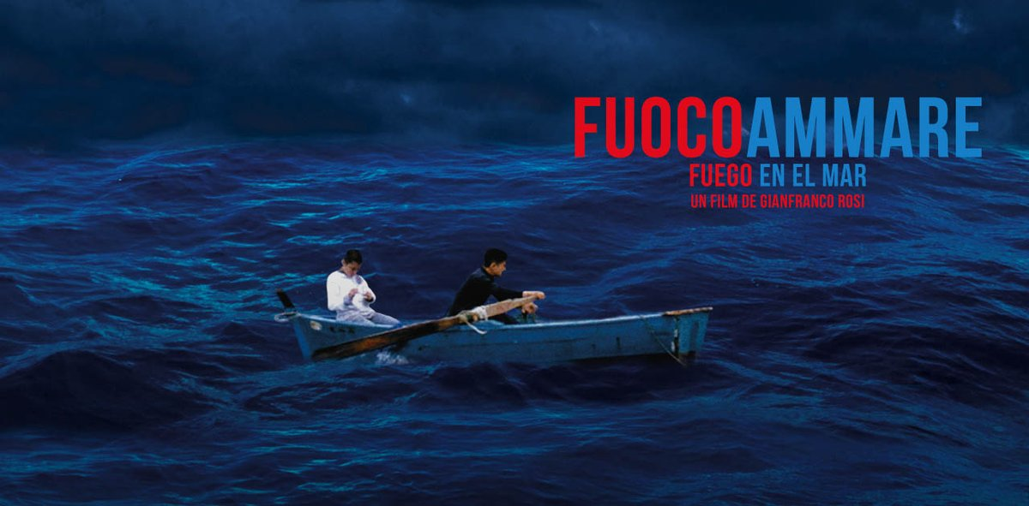

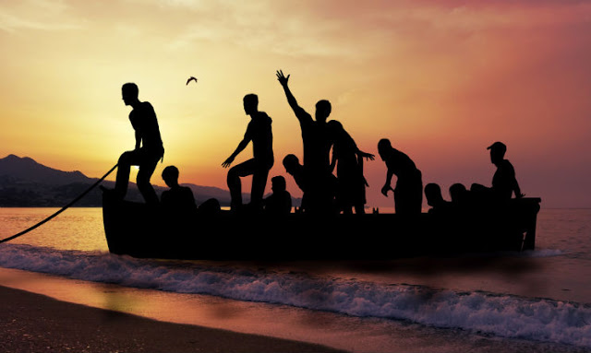

Trailer

Describe the style of film making
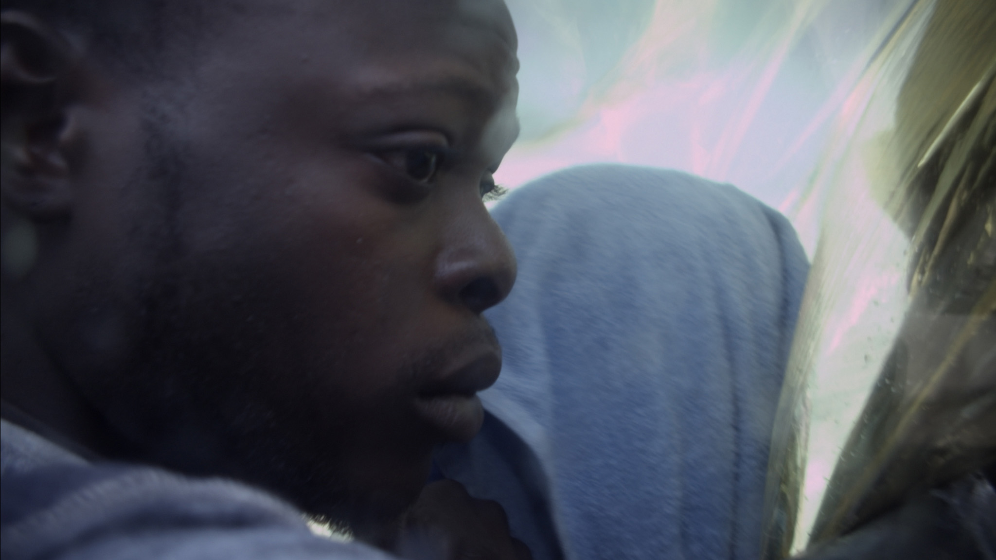

What devices, effects does the film maker use?
IndieWire story on

What is the effect of these devices, effects? Why did he chose them?

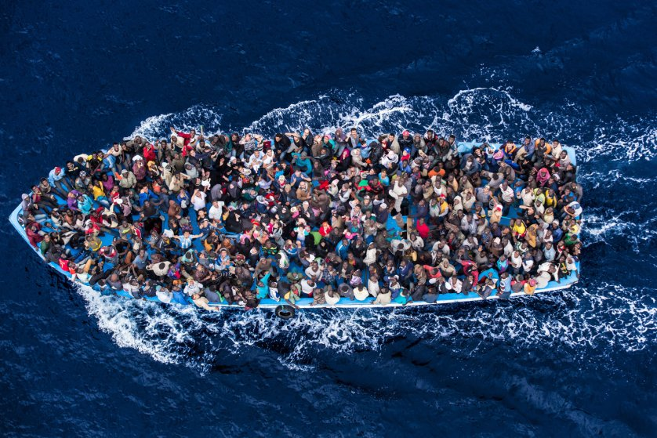

Director of both Sacro Gra and Fuoccoamare: Gianfranco Rosi
Guardian interview

jumping back and forth among vignettes, storylines, people

sound

helicopter, motorbike SO loud

boys, conversation, music, news: medium

images of people after rescue through plastic: silent
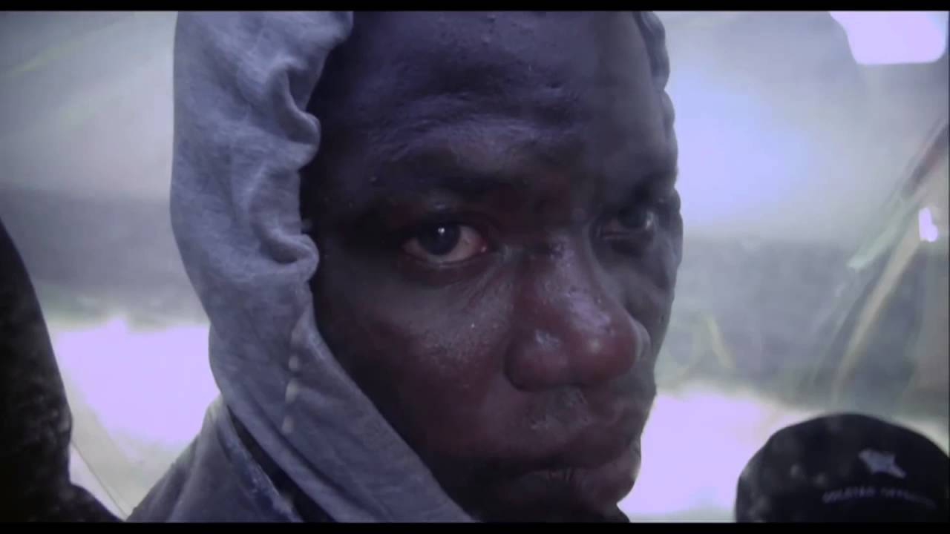

How do the Italians you see in the film treat the refugees?

What the take-away?

