What skills are needed to work in an academic library in the 21st century?

Term Paper: Stage III

Joanna Russell Bliss
University of North Texas INFO 5000
December 3, 2019

Abstract
Purpose: The purpose of this paper is to determine the recurring predicted trends for what technical skills librarians need to work in a 21st century academic library.

Design/methodology/approach: This paper compares and contrasts 10 research articles that discuss trends within librarianship, in the past, the present, and – most importantly – the future.

Findings: This paper provides some common themes that were found among the 10 papers that may help library science students, as well as current librarians, determine what skills they need to excel at their jobs. The author learned that technical skills like data management and analysis, digital publication, and information visualization may be important skills to have, but there are other, more prosaic skills that future librarians will also need, like collaboration, communication, advocacy and planning, while continuing to provide research support to both students and faculty and teaching information literacy in a variety of ways.

Keywords: Job, skills, technology, future, technical, librarian, roles

Paper type: Literature review
Introduction
The challenge of library science is that the technology used to access information and knowledge is perpetually evolving. In an academic library in 2019, understanding technology like search engines, or website layout and design, are key skills necessary for success.
But what is in the pipeline? What types of emerging technologies or disciplines are growing and may be required in the next 10 or 20 years? As people who constantly ask – and answer – queries, librarians often research these questions, trying to figure out “what new skills they expect to need in librarians in the next 20 years,” (Schwartz, M., 2016, p. 38.) They do literature reviews to determine the roles of librarians in academic libraries in the coming years (Allen & Taylor, 2017). And they ask specific questions about current services; the title of an article by Bandyopadhyay and Boyd-Byrnes (2016) says it all: “Is the need for mediated reference service in academic libraries fading away in the digital environment?”
This study aims to compare what librarians are predicting across a variety of publications, collecting trends to help people learn the necessary skills to excel as academic librarians in the 21st century.

Research questions
- What role will technology play in academic libraries in the next 10-20 years?
- What types of software and technology will librarians need to understand and use to work in this field?
- What new technological jobs or fields are emerging that may affect the roles of librarians in the next decade?

Methodology
Three databases were searched (Library & Information Science Abstracts, or LISA; Library Science Database; and Library & Information Science Source) using a Boolean search for “academic,” “librarian,” “technology,” “future,” and “skills.” The publication year was limited to 2016 or later, and the publication location was limited to the U.S. for the first two searches, resulting in around 250 articles for each search, but the filter was removed for the third search as it was a much smaller search result. That said, the final literature review only included articles that analyzed libraries in the U.S., with an emphasis on academic libraries.
Once these searches were complete, the abstracts were reviewed to rule out articles that focused on specialty libraries like law or medical libraries, or topics like the importance of diversity or inclusion that are indeed important but not related to this research. This led to these 10 articles focusing on the skills needed for librarians in academic libraries.

Literature review
The past
To look forward, one must first look back. When one thinks of forward-thinking librarians, Vannevar Bush comes to mind, with his prescient article “As We May Think” (Bush, 1945). Grappling with the return to life without war – and its horrors created by 20th century technology – Bush argued that the new role of scientists was to create new technology to allow researchers to find information more quickly. And it is true that the technology available to librarians has greatly changed and improved the work of librarians, allowing us to find information more quickly (if we know where to start looking).
On the other hand, in King’s (2016) discussion of the future of academic libraries, she focuses on the experience created for students in 1970 at Hampshire College – “a form of education that is not delivered through the traditional structure of the course and textbook, but is experience-based, learner-centered, and inquiry-driven” (p. 265).The college became an interdisciplinary center of research and examination, one that placed the library at the center of such scholarship. These shifts in our field show that librarians must adapt to both new technological skills and new roles as libraries evolve. As Gorman (1998) re-envisioned Ranganathan’s final law of library science, “the library is a growing organism,” librarians must “honor the past and create the future” (p. 23).
The present
Skills. The one skill emphasized for the past, present and future by King (2016) was collaboration. The vision of campus leadership at Hampshire College as described by King places the library as a hub where librarians not only support students and faculty in their research, but they also engage with the community for “experiential learning that facilitates collaborations between offices such as career options resource center, civil liberties and public policy; center for youth and learning… ethics and the common good; and the center for partnerships for social changes” (p. 267).
King (2016) also points out that Hampshire College does not stand alone with these ideas. She emphasizes that the standards for information literacy originally published by the Association of College and Research Libraries in 2000 underscore a shift from students simply finding answers to engaging in research and scholarly conversation. The updated Framework for Information Literacy for Higher Education, published in 2015, emphasizes King’s point even more, encouraging collaboration with both faculty and students on research, as well as the creation of “collaborative spaces” where students can produce and share information in “participatory digital environments” (American Library Association, 2015, Introduction; Research as Inquiry).
Roles. As these authors looked forward, many included discussions of the roles librarians currently play. Unsurprisingly, the most common current role mentioned by these authors was research support (Bandyopadhyay & Boyd-Byrnes, 2016; King, 2016; Maceli & Burke, 2016). Bandyopadhyay & Boyd-Byrnes question the relevance of a reference model that requires librarians to sit at a desk and wait for inquiry, particularly when many questions are coming in via chat or email and can be answered anywhere (p. 606). Maceli and Burke surveyed librarians that subscribed to a variety of online discussion boards; with more than 2,000 librarians responding, the most common task reported (in 63% of the responses) was reference (pp. 39-40). And central to King’s philosophy of the library as a center of inquiry is the librarian as research support for both faculty and students (p. 267).
Aside from research support, instruction was the second most common task performed by the librarians surveyed by Maceli and Burke (2016), and Bandyopadhyay and Boyd-Byrnes (2016) contend that part of the reason there is a lesser need for reference services is because librarians are spending more time in the classroom, teaching information literacy (p. 610). Maceli and Burke note that the third most important task for librarians (the last task reported for more than half of the librarians surveyed) is collection development. And Decker (2017) points out that librarians should be continuous learners, allowing them to keep up with the constantly changing technologies used in the library.
The future
Skills. So what was the consensus among these articles? What technological skills will academic librarians need in the future? One major skill cited by these authors was data management and analysis. Meredith Schwartz (2016) notes that data analysis is central to what librarians need to do: Tomorrow’s librarians will be “identifying the data needed to make decisions; knowing how to collect, analyze, and gain insight from that data; and presenting the accompanying narrative to explain it to others” (p. 39). Maceli and Burke (2016) observe in their discussion that only a small group of librarians have jobs that require them to program software, but they imply that the fact that the most common skills librarians want to learn is “coding or programming” shows that having a general understanding of these skills would help librarians work with more complex technology (p. 52). Decker (2017) cites information management as one of three key skills librarians will need as libraries evolve (p. 290). And Allen and Taylor (2017) place information and communication technologies (ICT) as key tools for librarians in the 21st century, allowing “users to access, store, disseminate and direct information” (p. 4).
Another common theme found in these articles was the importance of digital publication. Meredith Schwartz (2016) refers to this skill as “Web development (and ‘whatever comes next in that space’)” and classifies it under the technological expertise needed for future librarians (p. 39). Both Allen and Taylor (2017) and Maceli and Burke (2016) note the importance of website publishing skills for 21st century librarians (Allen & Taylor, p. 4; Maceli & Burke, p. 46). And Fong (2017) argues that the shifting nature of dissertation publication means that librarians should be prepared to help Ph.D. candidates produce dissertations in new formats like “scholarly articles and digital or Web-based projects” (p. 132).
Two authors suggested that we need to be looking at information in new ways. Judith Schwartz (2018) explains that we have become a visual society, surrounded by images. According to Schwartz, this shift to a “visual culture” means that librarians need to expand their teaching of information literacy to include visual literacy; the librarians she surveyed agreed that “visual literacy is important across all disciplines” (pp. 479 & 490). And Chen (2019) advocates for the digital humanities and information visualization. She explains that information visualization requires a variety of technological tools and applications and concludes that “the purpose of most of the information visualization–related work in the digital humanities is to analyze and discover. Thus, academic librarians should also be able to envision the visualization results through an analytical lens” (Chen, p. 601).
Other necessary skills are important for leaders in any field. Both communication (Allen & Taylor, 2017; Decker, 2017; Schwartz, M., 2016) and collaboration (Allen & Taylor, 2017; King, 2016; Schwartz, M., 2016) were noted as crucial skills for future librarians. While Allen and Taylor may classify ICT as a technical skill, it is a technological tool allowing librarians to communicate with patrons. And King’s vision of a “learning commons 3.0” at Hampshire College includes the image of the librarian as an “academic concierge” who “brings together research librarians, the CTL [Center for Teaching and Learning], the quantitative resource center, transformative speaking program, student success, and writing center, to function as a community of practice that shares knowledge, practices and strategies” (p. 271). Planning and organizational skills will also continue to be valuable in the library. Meredith Schwartz points out the significance of both critical thinking and project management skills, “including scheduling and capacity planning,” as well as “budgets, facilities, and grant writing” (p. 39). Likewise, Decker asserts that learning environments, in the library or otherwise, will have a better chance of success if the activities are “planned, organized, and evaluated” (p. 287).
Roles. Compared to the evolving technology in use, the roles librarians will fulfill are predicted to remain steady. One of the central tenets of academic libraries, research support, will remain important. Decker (2017) points out that while librarians will continue to use “traditional” skills for research support, the training they will need will relate to the technology they will be using (p. 289). In the same way, when Allen and Taylor (2017) list the expected competencies for 21st century librarians, research support is still a part of that list (p. 4).
As our digital world continues to grow and evolve, teaching information literacy, or IL, will become an even more important part of librarian education and collaboration. Edwards (2018) suggests that librarians should be teaching a full 3-hour course on information literacy, incorporating IL, writing and research into a course included in the general education curriculum often completed by freshmen and sophomores before moving on to higher level classes (pp. 291-292). Allen and Taylor (2017) include the teaching of IL in a broader discussion of how librarians should be considering both e-learning and distance education when planning the educational resources available at the library. And as with her conversation about research support, King (2016) notes that librarians will continue to teach information literacy, but it may be taught using newer technologies that require training and continuing education before use (p. 289).
The final role that was mentioned by multiple authors for future librarians was as an advocate. This role is not new to librarians; one could argue that Bush’s (1945) article in The Atlantic Monthly was his way of advocating for the profession. Both Meredith Schwartz (2016) and Allen and Taylor (2017) mention the continued need to promote and market the services and resources available through the library of tomorrow (Allen & Taylor, p. 4; Schwartz, M., p. 39). But Schwartz goes one step further to argue that librarians should be advocates in the political sense, “raising awareness of value among stakeholders, with an eye to maintaining or increasing funding, and building community, organization, and outreach, with an eye to expanding those services and effectively serving the constituencies who need them” (p. 38).

Discussion
Based on this literature review, technology will continue to play a central role in libraries in the 21st century. Whether it will be for data management, digital publication, information visualization – or something new that hasn't yet been developed – librarians will not only need to be able to use technology to manage and disseminate information, they will need to be able to show others how to access and interpret information with that technology; as Maceli and Burke (2016) learned from their survey of librarians, teaching others how to use technology is one of the most common roles for librarians, and it's unlikely to change as the use of technology will only expand more (p. 41).
This author agrees with Allen and Taylor (2017) that access to resources no longer means going to the library – cloud computing and access to e-resources will only expand as digital collections grow (p. 3). They have a valid point about the expansion of information communications and technologies (ICT): "the ongoing evolution of learning is moved forward by ICT" (p. 4). This means that academic librarians will need to be fluent in all of the latest ICT tools, in order to not only communicate with colleagues within the library, but also with students and faculty. In addition, the continuing expansion of e-learning at most, if not all, universities, means that academic librarians will need to be prepared to make sure all resources are available for all students, whether they are on-campus or learning from a distance (Allen & Taylor, p. 5). Interlibrary loan will continue to be an important part of this sharing of resources, particularly as libraries may be reducing print collections in order to create more collaborative spaces for students like those described by King (2016).
There were not a lot of specific software names thrown out in these articles, but certain skills bear mention. As more and more patrons access materials through library websites, web design and capability will only grow in importance. This is most likely why Maceli and Burke (2016) found that the top two skills that librarians wanted to learn were coding or programming, and how to manage web content (p. 46). Fong (2017) suggests that academic librarians will need to begin supporting a variety of formats for dissertations, rather than simply text-based papers. In Fong's eyes, this may be as simple as allowing for multiple authors on a paper published as an article, but it also extends to the building of support for digital projects, which means that librarians would need more technical skills to assist the creators of such projects (pp. 130; 132).
While only three of the articles emphasized collaboration (Allen & Taylor, 2017; King, 2016; Schwartz, M., 2016), this author believes this is an important part of librarianship as the field shifts away from not only the storage and location of resources, but also helping students and faculty engage in scholarly conversations emphasized in the ALA's Framework for Information Literacy for Higher Education (2015). Considering Judith Schwartz's (2018) emphasis on visual literacy, perhaps librarians will need to re-evaluate how they teach information literacy, moving beyond the information literacy described by Edwards (2018) to create new programs that broaden the concept to "metaliteracy," mentioned by Schwartz but originally conceived by Mackey and Jacobson in 2011 (p. 482). And if the field of digital humanities continues to grow, as Chen seems to think it will, librarians will need to work with subject experts and technical experts to create information visualizations. This may not require librarians to know everything about each component of the project, but they will need to understand how much time (and money) is required for each component, as well as how to manage the process.
Collaboration is also key to managing the library, now and in the future. Librarians must work together to re-envision current spaces and plan for new challenges, like the evolution of library spaces described by King (2016). And only by working with both inside and outside groups can librarians truly advocate for the profession and their organizations, making sure they have necessary budgets to accomplish annual goals, and giving them the ability to approach donors and grant organizations for that next big technological innovation.
Finally, while all of these articles discuss what librarians may be doing in the future, few suggested what their future titles might be when needing these skills. Both Maceli and Burke (2016) and Bandyopadhyay and Boyd-Byrnes (2016) skirt the issue by discussing job listings without specifying actual titles. Chen (2019) only mentions job titles in passing in her introduction, noting "new job titles in LIS have emerged from this significant trend in data and visual analytics, such as data and visualization librarian, and visualization and digital media librarian" (p. 592); she doesn't give any further analysis on other titles within the field, or the particular importance of these specific titles. But given the wide range of titles found in prior research for job titles dealing with user experience in academic libraries, Decker (2017) hits the nail on the head with her analysis of what is important as library science students work on degrees and begin job searches. As she explains in her introduction, "Without a clear understanding of which job titles will continue to reside within the academic library of the future, library managers have worked to consider the skill sets that will most likely be required of library professionals as the landscape develops," (Decker, p. 286). It's far more important that future librarians are prepared with the skills necessary for the new era of librarianship, regardless of what the job titles might be.

Conclusion
Preparing for the unknown, whether it's a new city, a new family member, or a new profession, can be daunting. As researchers, future (and current) librarians can prepare for the future with more knowledge than the average professional, by learning from others who have analyzed the trends and can see emerging patterns. Yes, these patterns relate to new technical skills, as well as current research-related roles, but they also point to general skills that are important in a variety of fields: communication, collaboration, and planning, as well as the ability to advocate for one's profession. The best we can do is to remember that to be successful in any position, we must follow the example that Decker (2017) suggests: Embrace the idea of continuous learning. We must learn what we can while we prepare for our degree, but know that as new technologies continue to emerge and shift our field, we will continue to learn on the job and adjust as necessary.

References
Allen, L. E., & Taylor, D. M. (2017). The role of the academic library information specialist (LIS) in teaching and learning in the 21st century. Information Discovery and Delivery, 45(1), 1-9. doi:10.1108/IDD-09-2016-0030
American Library Association. (2015). Framework for information literacy for higher education. Retrieved from http://www.ala.org/acrl/standards/ilframework
Bandyopadhyay, A., & Boyd-Byrnes, M. K. (2016). Is the need for mediated reference service in academic libraries fading away in the digital environment? Reference Services Review, 44(4), 596-626. doi:10.1108/RSR-02-2016-0012
Bush, V. (1945). As we may think. The Atlantic Monthly, 176(1), 101-108. Retrieved from https://www.theatlantic.com/magazine/archive/1945/07/as-we-may-think/303881/.
Chen, H. M. (2019). Information visualization skills for academic librarians: A content analysis of publications and online LibGuides in the digital humanities. Library Hi Tech, 37(3), 591-603.
Decker, E. N. (2017). Encouraging continuous learning for librarians and library staff. Library Management, 38(6), 286-293. doi:10.1108/LM-10-2016-0078
Edwards, J. B. (2018). Added value or essential instruction? Librarians in the twenty-first-century classroom. Reference & User Services Quarterly, 57(4), 285-293.
Fong, B. L. (2017). An exploration of changing dissertation requirements and library services to support them. Portal: Libraries and the Academy, 17(1), 129-144. doi:10.1353/pla.2017.0008
Gorman, M. (1998). The five laws of library science, then and now. School Library Journal, 44(7), 20-23.
King, J. G. (2016). Extended and experimenting: Library learning commons service strategy and sustainability. Library Management, 37(4), 265-274. doi:10.1108/LM-04-2016-0028
Maceli, M., & Burke, J. J. (2016). Technology skills in the workplace: Information professionals' current use and future aspirations. Information Technology & Libraries, 35(4), 35-62.
Schwartz, J. (2018). Visual literacy: Academic libraries address 21st century challenges. Reference Services Review, 46(4), 479-499. doi:10.1108/RSR-04-2018-0048
Schwartz, M. (2016). Careers: Top skills for tomorrow's librarians. Library Journal, 141(4), 38.

Appendix A
Literature map, noting common themes among reviewed articles.
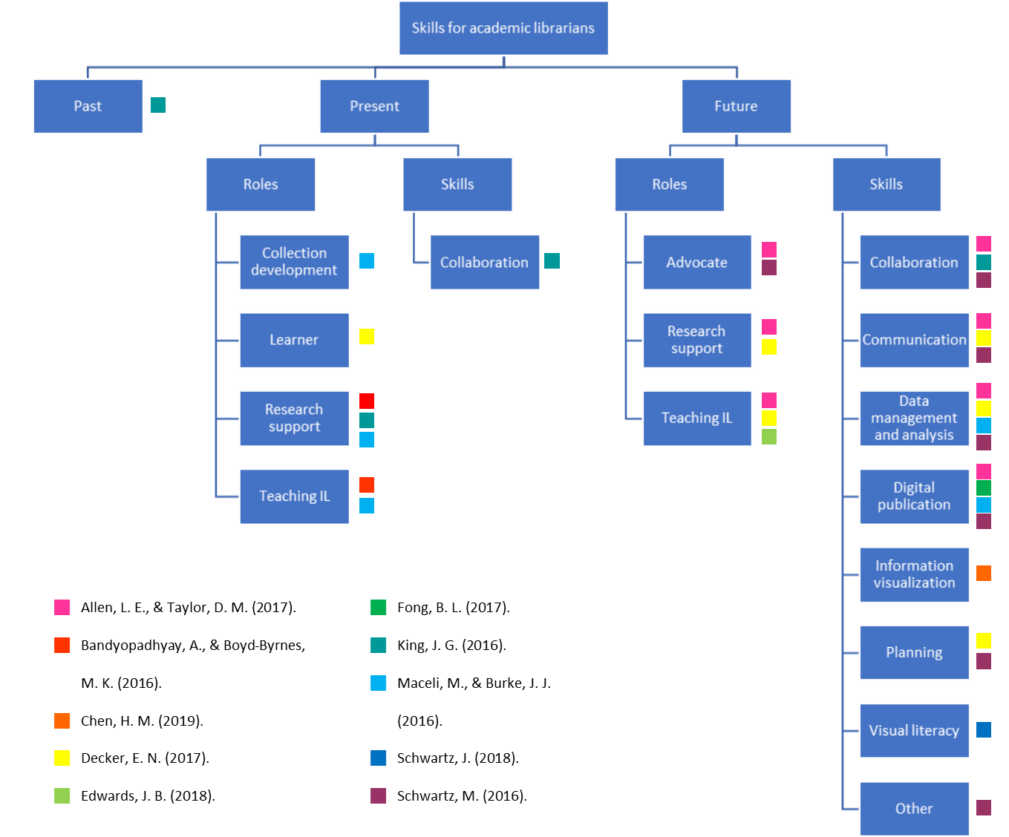
Appendix B
Screenshot showing the “Write & Cite” function of RefWorks.
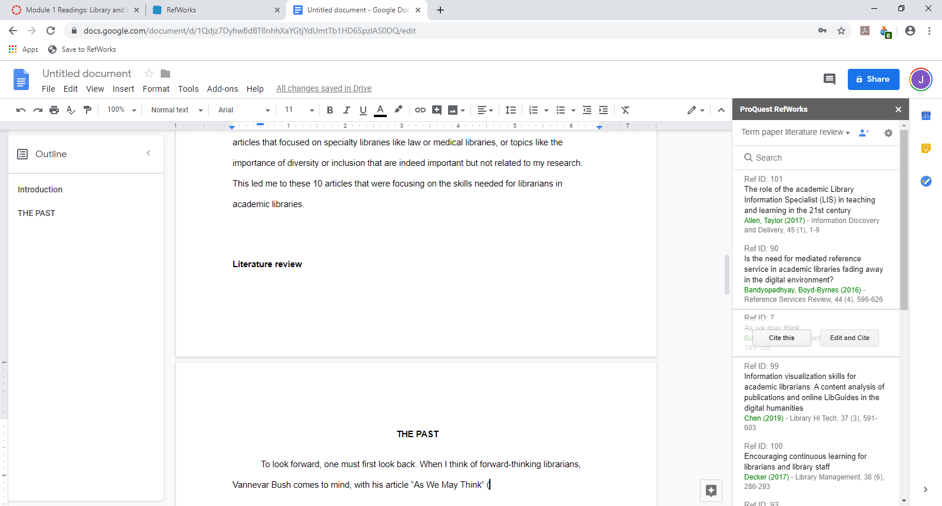
Screenshot of creation of bibliography in RefWorks.

