Comparative European Politics
Understanding the French Immigrant Experience: Fatima
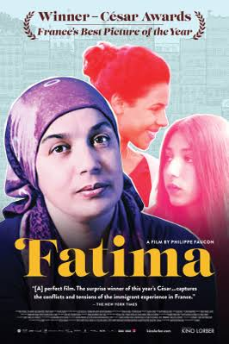
Fatima
Trailer here - Recap here – a film of “invisibles” people like Fatima, a house cleaner who has to listen to her ‘madame’ tell her how to clean the bathtub by day and by night writes poetry

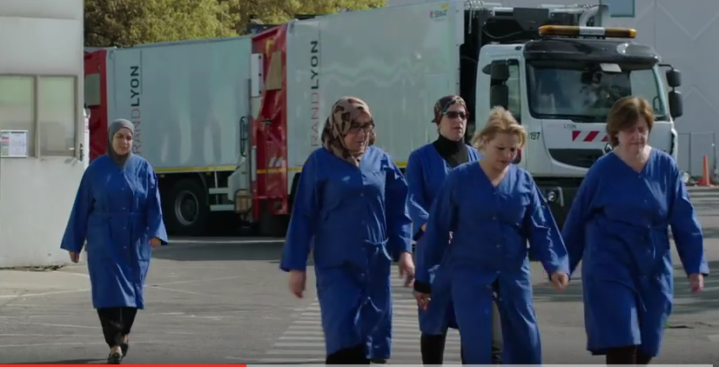

What did the film reveal about the lives of Moroccan immigrants in France today?

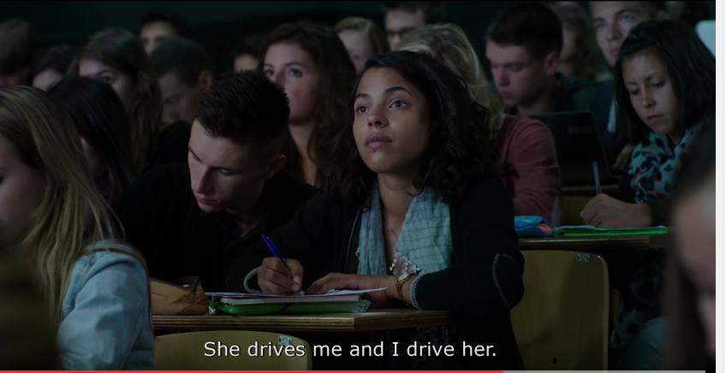

What stereotypes did it seem to support?
About immigrants, esp. Muslim women, in France?
About France, French political culture or society?

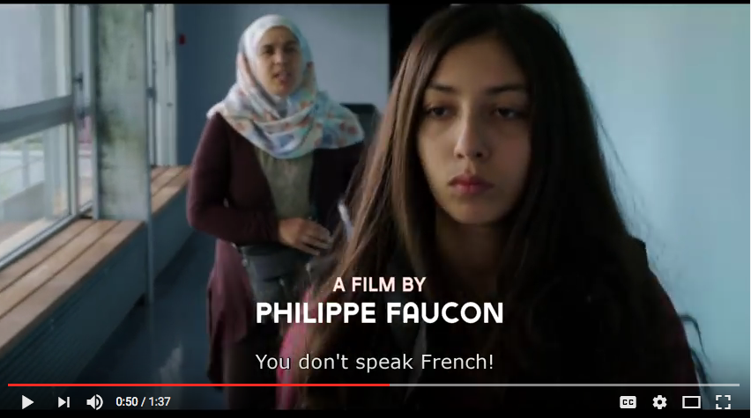

What stereotypes did it seem to undermine or dispel?
About immigrants, esp. Muslim women, in France?
About France, French political culture or society?
