Global Gender Regimes
Introduction to Feminist IR
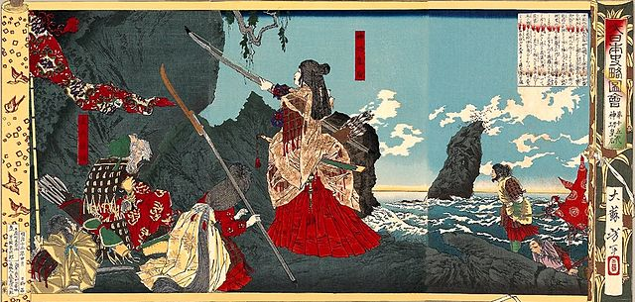
Trigger warning: this lecture includes images from war and references to sexual violence that are disturbing and may trigger a trauma response.

Why do we need feminist IR?
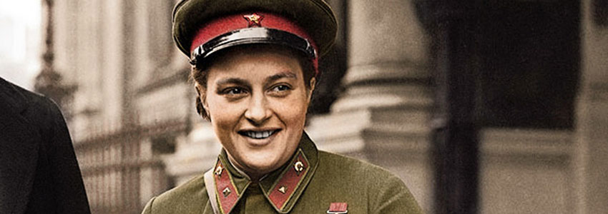

Women as warriors, rulers, diplomats, brides, mothers, wives, peacemakers, victims, “spoils of war”

Mass rape as a military tactic

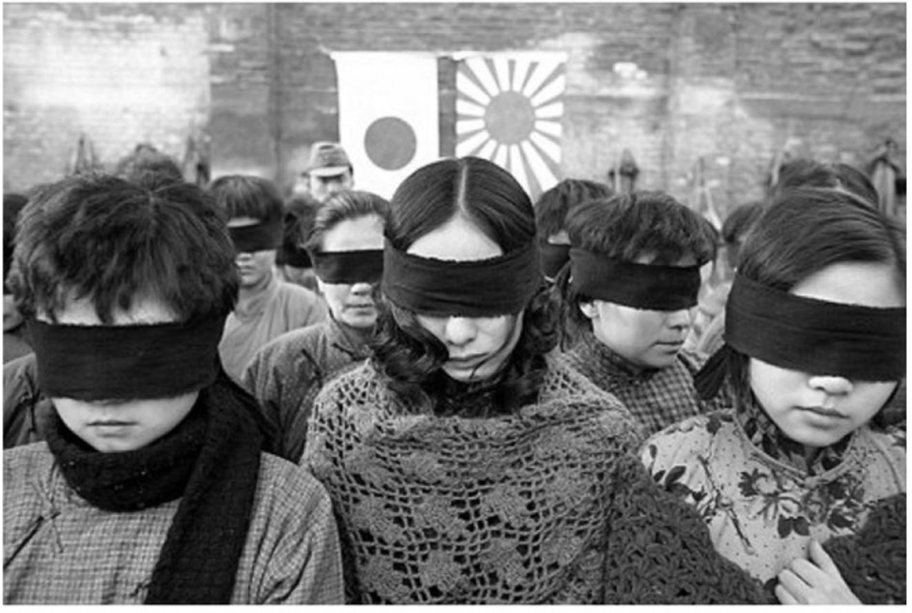
more on Nanking
“liberation” of Berlin by the Red Army
Memoir: A Woman in Berlin
Film
sexual violence in the Holocaust
book on
Srebrica
Rwanda

Catherine MacKinnon’s book Are Women Human?
Notes on
International Criminal Court – rape as a tactic of genocide

Organized military sexual exploitation and violence

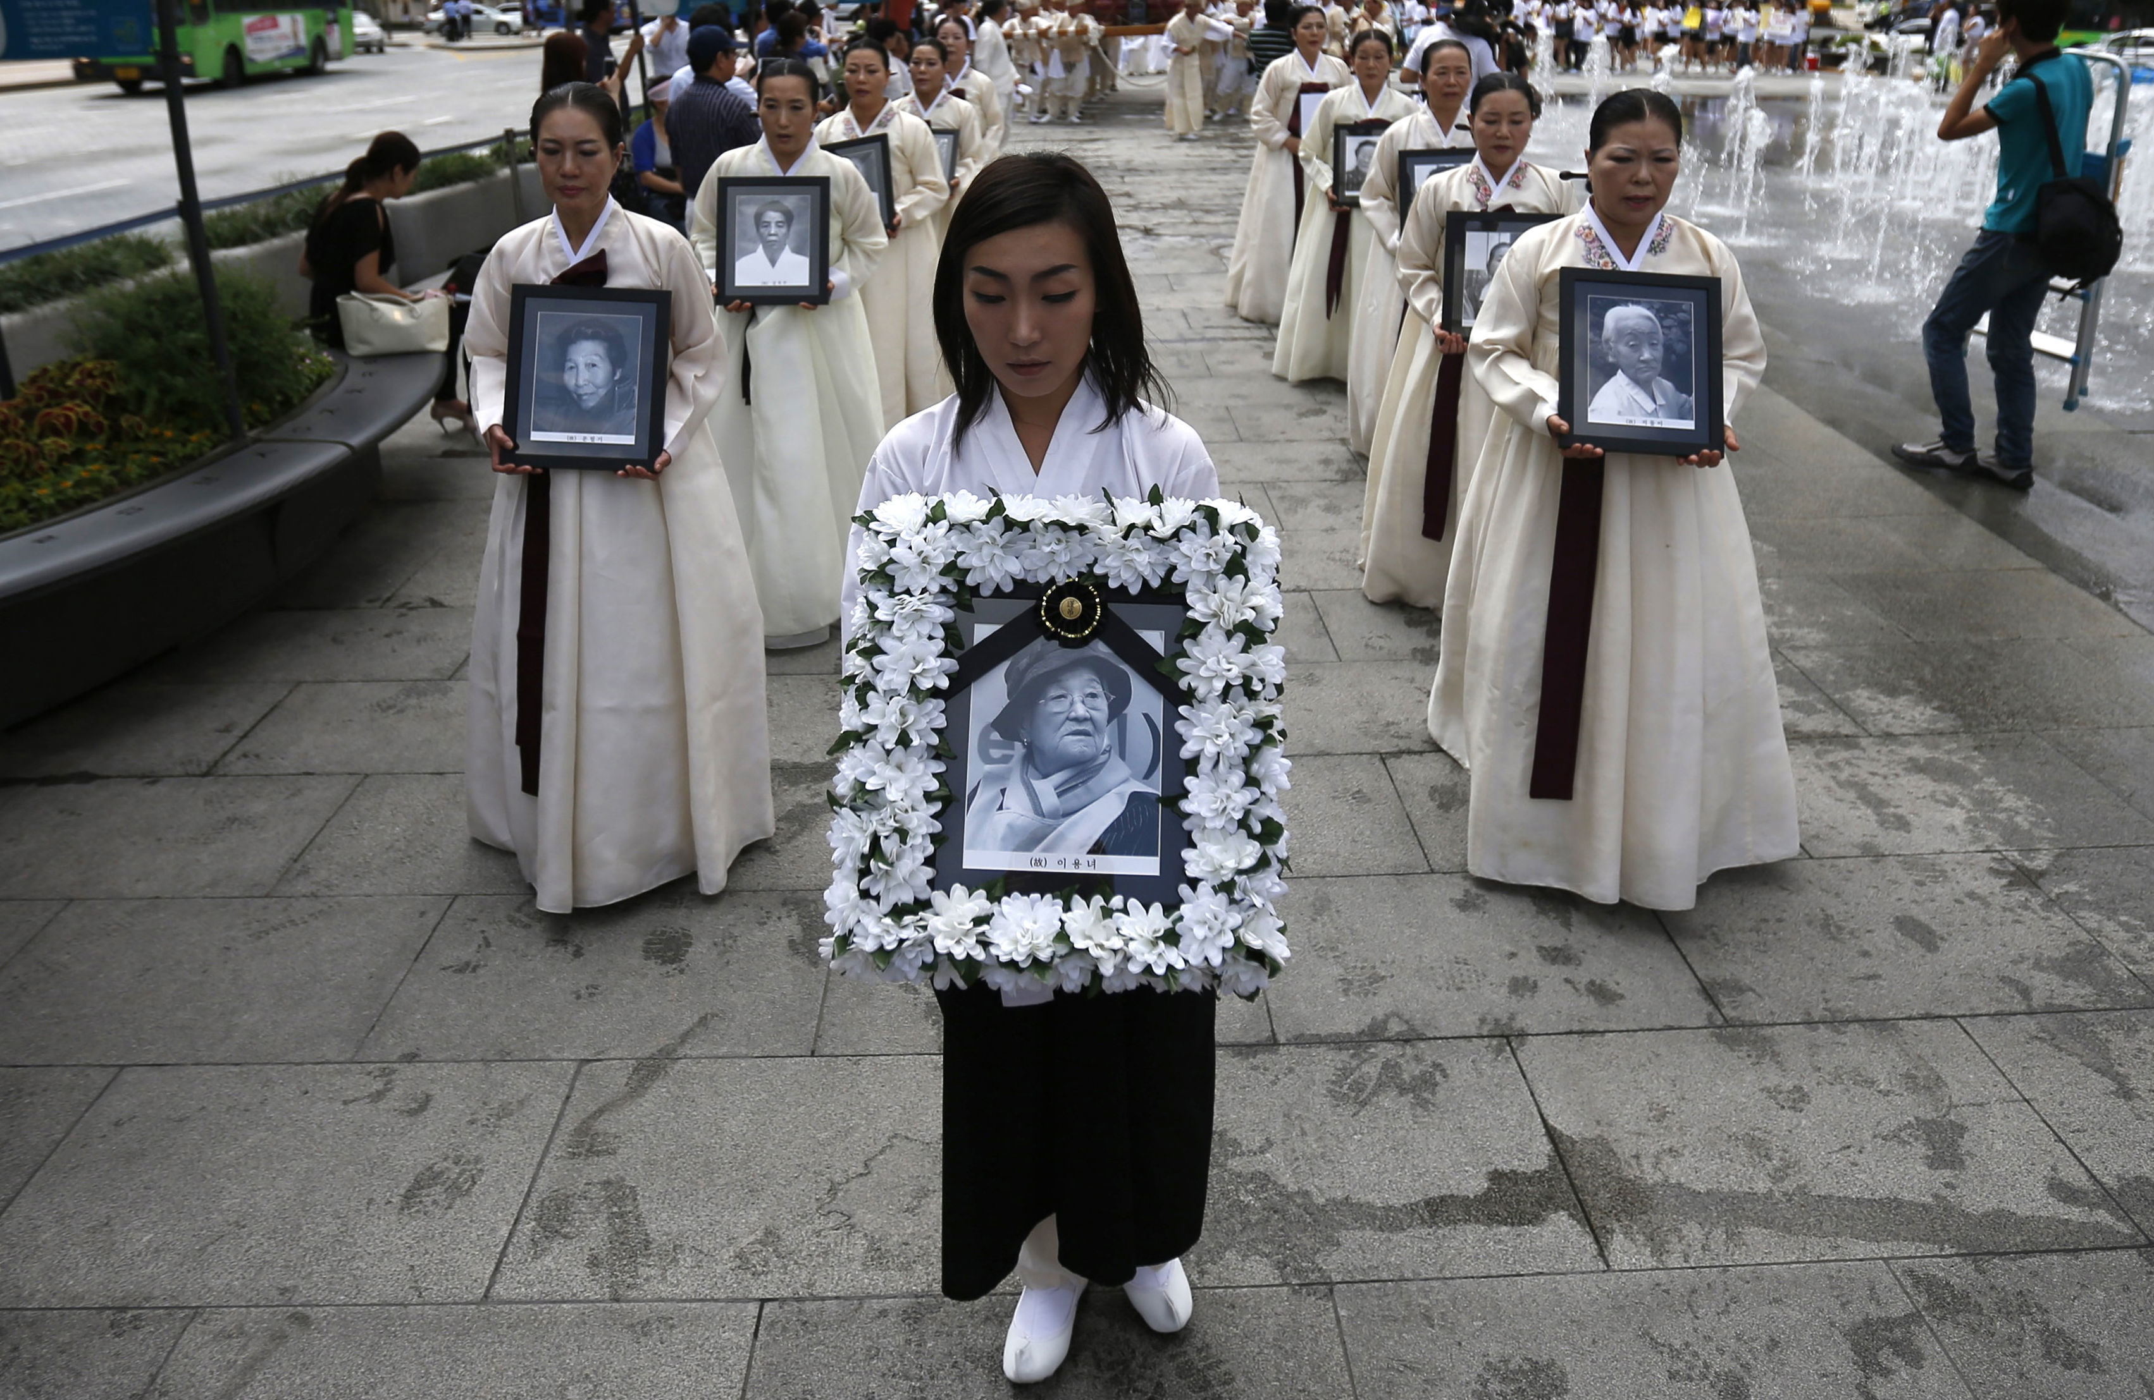

“womenandchildren”

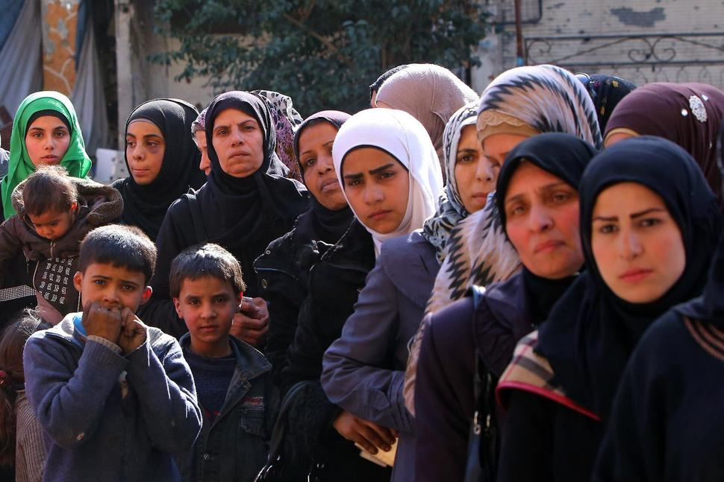
Most Syrian refugees “womenandchildren”

Types of feminist IR reflect different kinds of feminism
Liberal – women’s rights are human rights; MacKinnon on
Marxist – IPE; Enloe, e.g.
Cultural, difference – MacKinnon on sexual violence as endemic to patriarchy, masculinity; Ruddick – on maternal ethics; Gilligan – moral reasoning.
Standpoint theory – feminist epistemology; Sandra Harding
Post-structuralism (post-modernism) – Scott on

The Politics of Difference: Are women naturally more pacificist than men?

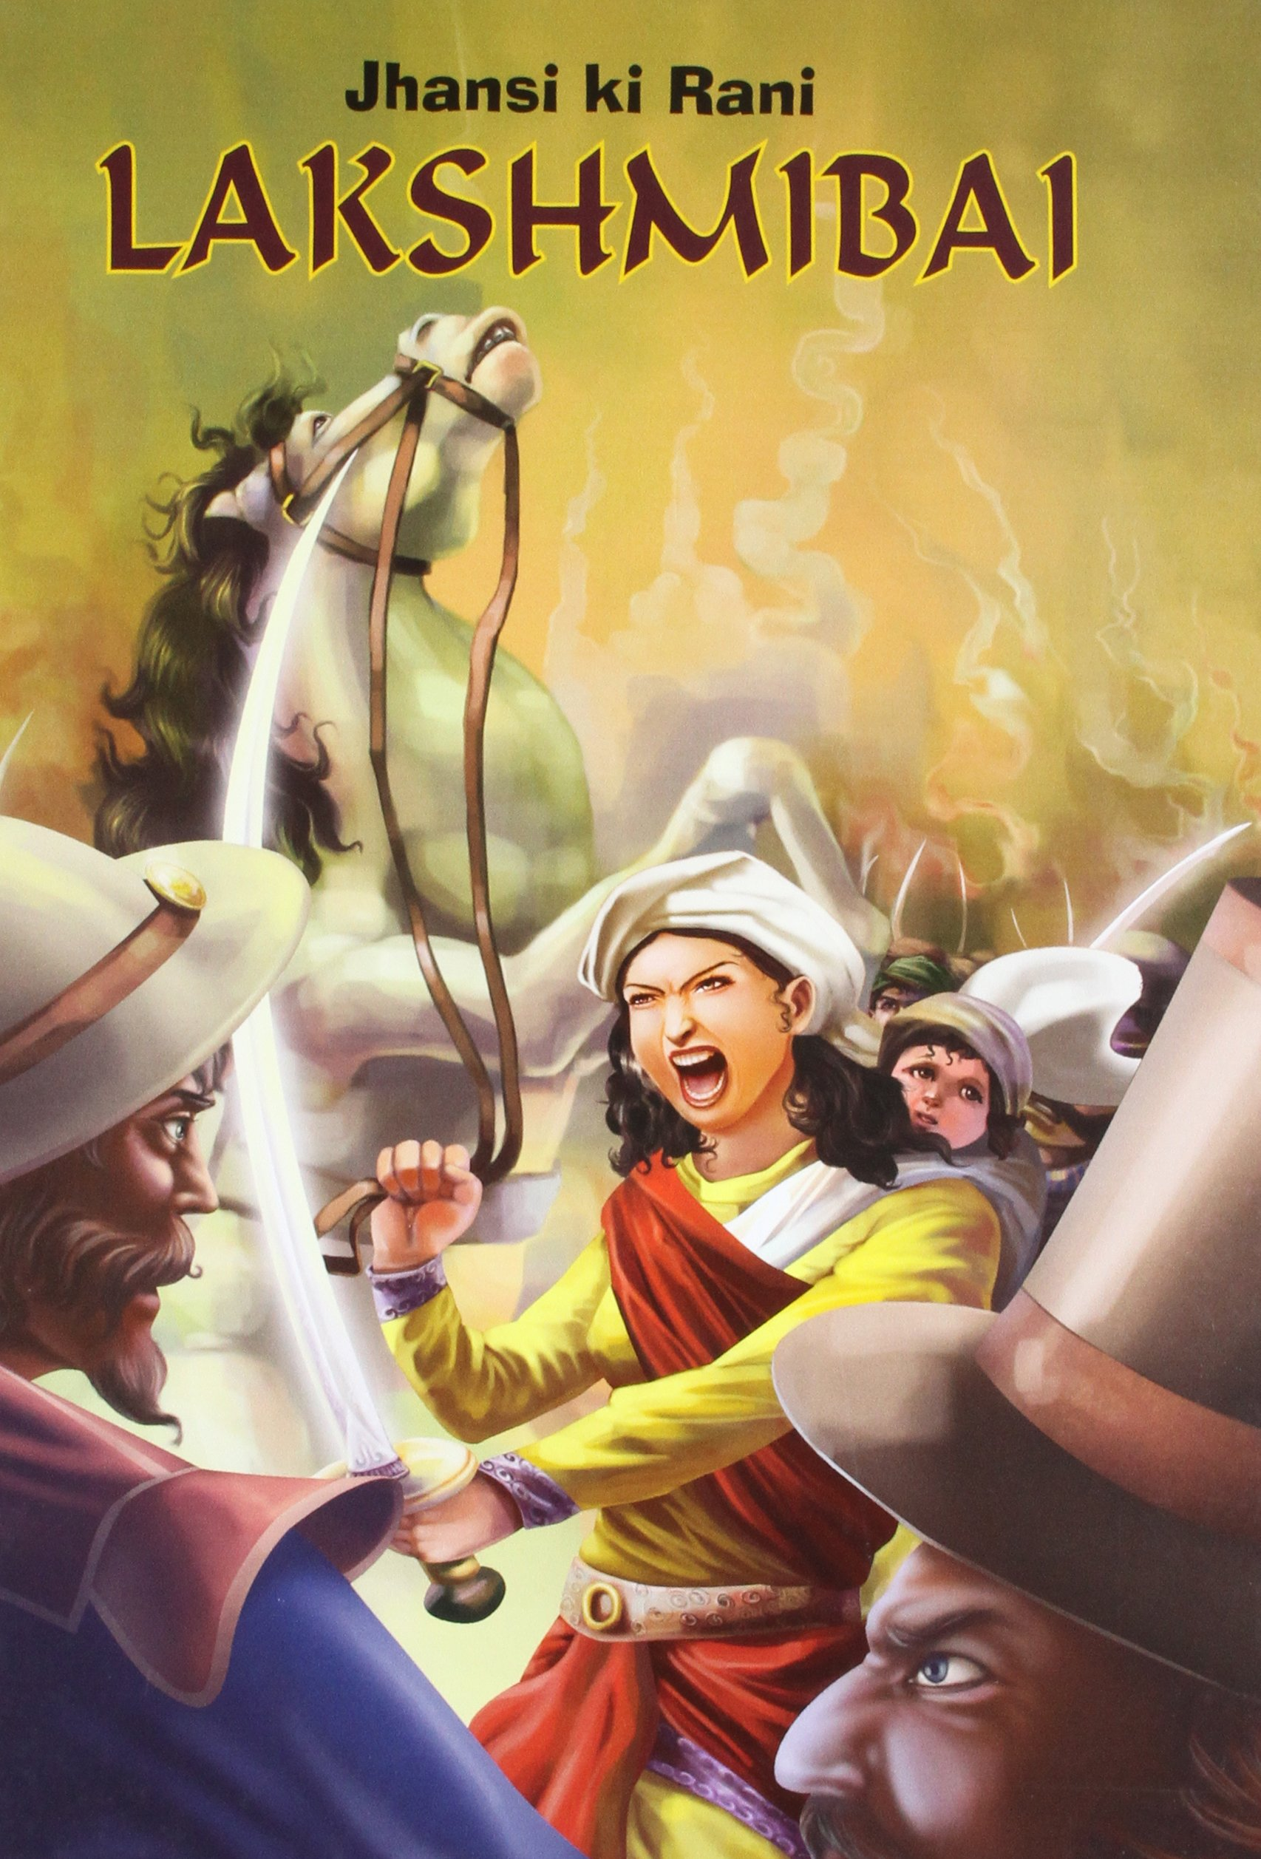

Post-structuralist’s answer: Sjoberg and Gentry Mothers, Monsters, Whores

